Ansible

quick guide for running in ubuntu on windows

Run your first ansible commands and ansible playbooks

Use ansible to configure IBM MQ running on linux on IBM Cloud Bare Metal Server

Use Ansible to interact with RHOCP cluster using SSH and Kubectl/OC

Use Ansible to interact with RHOCP pods using k8s connection plugin (TBD)

Dave Arnold

May 2020

Contents

Enable Linux subsystem on Windows 7

Set up ubuntu users and passwords 9

Set a root password 9

Updates and installation for ubuntu 10

Install ansible 11

Check ansible version 11

Get details for an IBM baremetal server 11

Test SSH into baremetal server from ubuntu on windows 12

Create the inventory file - hosts 13

Install sshpass 14

Test and ansible command - ping 15

Create a playbook to test 15

Test and ansible playbook 16

Set up ansible.cfg file 16

Retest playbook without -i 18

Run a linux command on the bare metal server 18

From the command line 18

Create a playbook to run a linux command 18

Run a command to create a file on the bare metal server 18

From the command line 18

Create a playbook to create, display and remove a file on baremetal 19

Modify ansible.cfg to remove command warnings 20

Re-run the playbook 21

Install a Test MQ system on baremetal 22

SSH into baremetal server from ubuntu on windows 22

Set up for MQ Install 22

Download MQ 22

Install supporting packages 23

Check the mqm user 25

Unpack MQ and accept the license 25

Debian install of MQ 26

Check install logs 27

Install bc 27

Check the MQconfig 28

Set up current user limits 28

Create a queue manager 30

Start the queue manager 30

Configure the queue manager for remote connection 30

Create an MQSC file to enable remote (client) administration 31

Define and start a listener 32

Create an mqsc file for Ansible to run 32

Local test of mqsc 32

Create a shell script to run the command 33

Connect MQ Explorer 33

Review the queues on mytektqmgr 35

Delete the ANSIBLE.Q 35

Using Ansible to administer the MQ queue manager 36

Using command line with the ansible RAW module 36

Using a basic playbook with RAW module 37

Exploring Ansible with Kubernetes 39

References to Tekton and MQ on RH Openshift 39

Documentation 39

Install Kubectl and OC clients on Baremetal server 39

Download and install the Kubectl client 39

Download and install the OC client 39

Test connection to cluster manually from Baremetal server 40

Get the K8s cluster token 40

Test OC client 40

Test Kubectl client 40

Using SSH to run kubectl/oc commands 41

Using Ansible command line 41

Create a pipeline run YAML on baremetal server 42

Use ansible command line to kick off the pipeline from Linux subsystem 43

Using the Ansible K8s connection plugin on Linux subsystem 46

Install the K8s connection plugin on Linux subsystem on Windows 46

Test Connectivity to the cluster from Linux subsystem 46

Get the cluster login command 46

Ping the Console from baremetal server 46

Test OC client from linux subsystem 46

Test Kubectl client 47

Set up Ansible for k8s connection plugin 48

Useful links 48

K8s inventory source – k8s.yml 48

K8s.yml file config 48

Write a playbook to test the K8s plugin from linux subsystem 49

Run ansible playbook 50

Reconfigure playbook to run against MQ pod 51

modify ansible.cfg to fix unreachable error 51

Rerun the playbook for MQ 52

Turn off gather facts as MQ container has no python 53

(re)Configuring MQ with Ansible via Config maps 55

Manually investigating Config Maps and Deployment Configs 55

Create a config map with an MQSC file 55

Some examples of config Maps with volumes – deployment and pod 56

Modify an MQ deployment config to reference the configMap 59

Final DeploymentConfig for MQ to run MQSCs from ConfigMap 62

Check the Pod has restarted based on the Deployment Config change 65

Using Ansible to change the configMap 66

Set up the baremetal command line environment 66

Using Ansible command line 66

Quick connectivity test from Linux subsystem via baremetal 67

Create/change the configMap MQSC YAML on the baremetal server 67

Use ansible command line for the apply of the ConfigMap change from Linux subsystem 68

Use ansible command line to restart the Pod from Linux subsystem 69

Appendices 71

Appendix A – bin/bash into containers 71

Appendix B – MQSC files in Config maps 73

Understanding the use of secrets to pass MQSC files at deploy time. 73

Instructions for the use of a configMap to pass MQSC content 73

Github repository source of instructions 73

Downloading the helm charts 73

Create a configMap within OpenShift 73

Customize the helm chart 74

Deploy the helm chart 74

Instructions for off cluster MQ connectivity using configMaps. 75

@DA@ notes on using configmaps with MQ and Tekton work 79

Other links 80

## Enable Linux subsystem on Windows

Search for Windows features in the search box. And when the “Turn Windows features on or off ” appears, click on that.

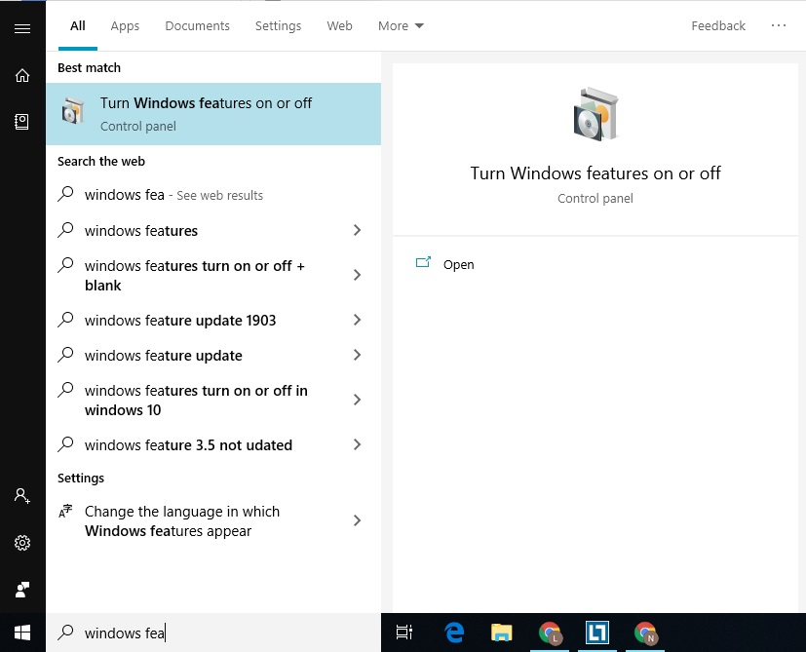

Scroll down and check the box of **Windows Subsystem for the Linux** option.

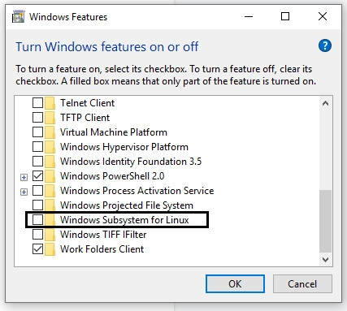

Windows will need a restart at this point

Open the Microsoft Store and search for Ubuntu to install the latest version.

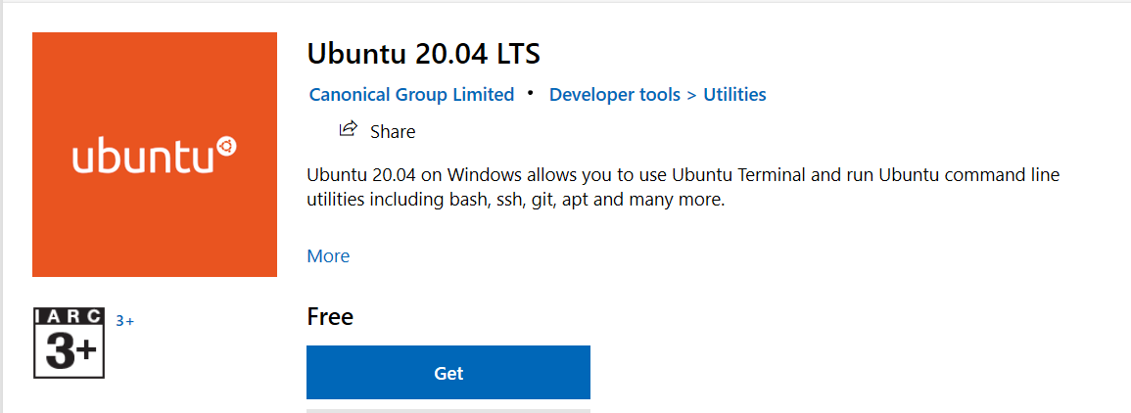

After the installation, you will see a launch button, use that to open the Ubuntu bash.

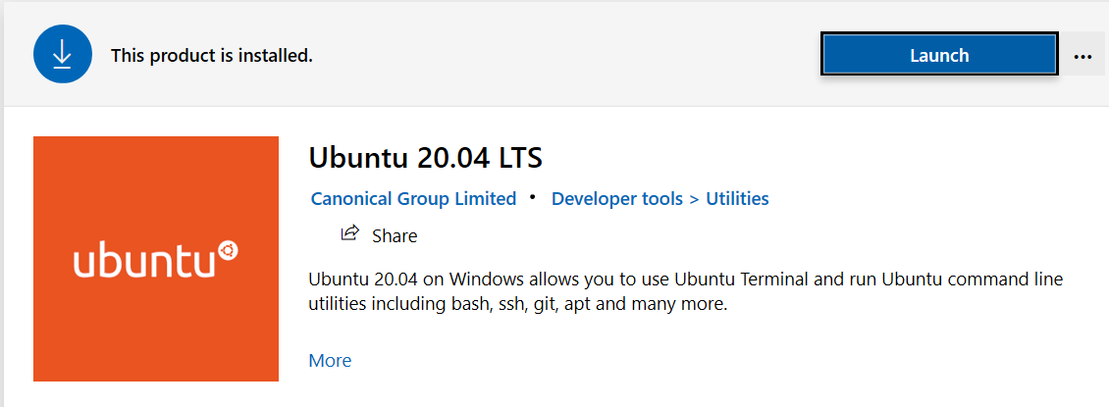

## Set up ubuntu users and passwords

Ubuntu bash, it will ask you to set the username and password for the default user

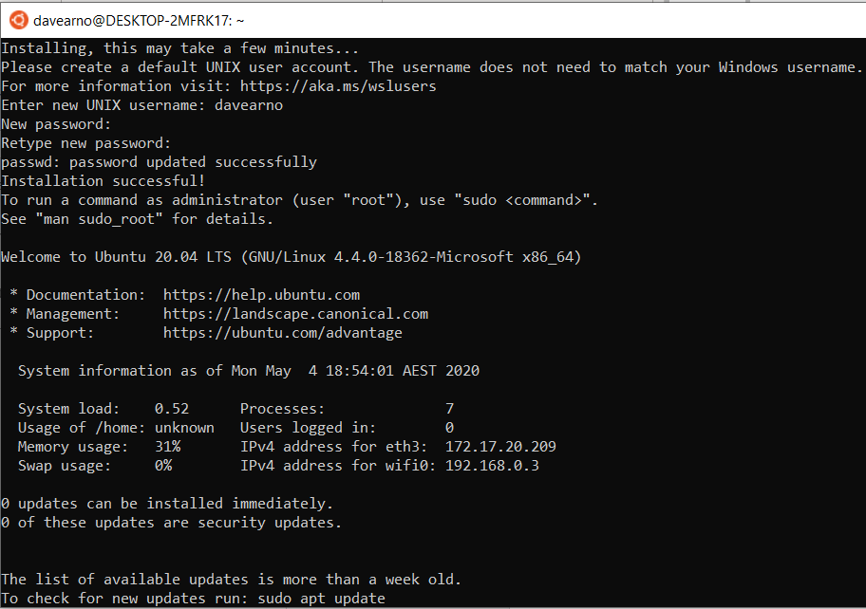

Davearno/passw0rd

### Set a root password

**sudo passwd root**

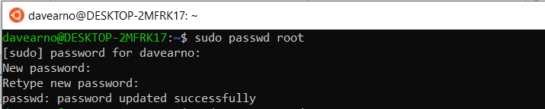

Root/passw0rd

## Updates and installation for ubuntu

**sudo apt-get update**

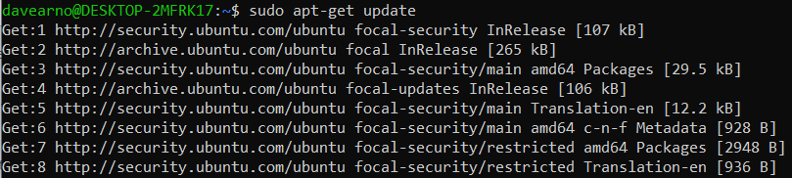

sudo apt-get install software-properties-common

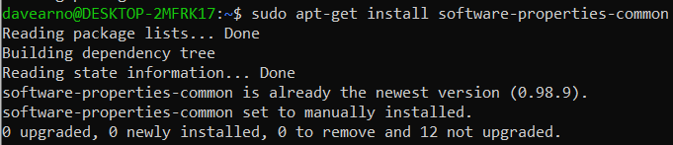

sudo apt-add-repository ppa:ansible/ansible

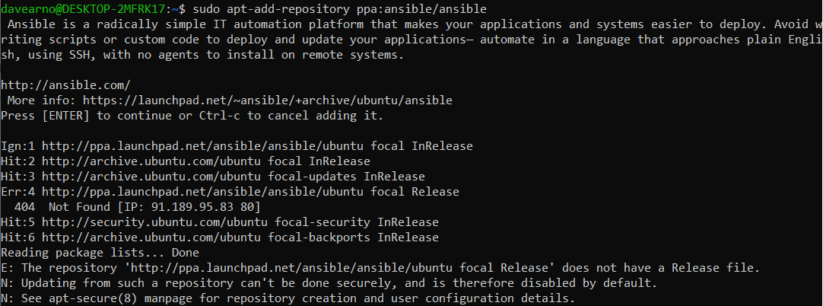

sudo apt-get update

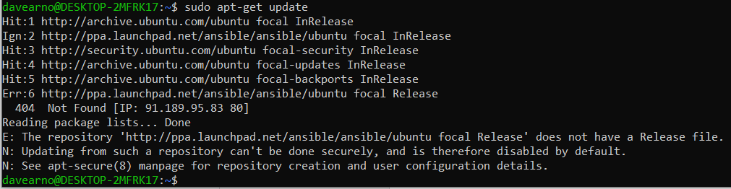

### Install ansible

sudo apt-get install ansible

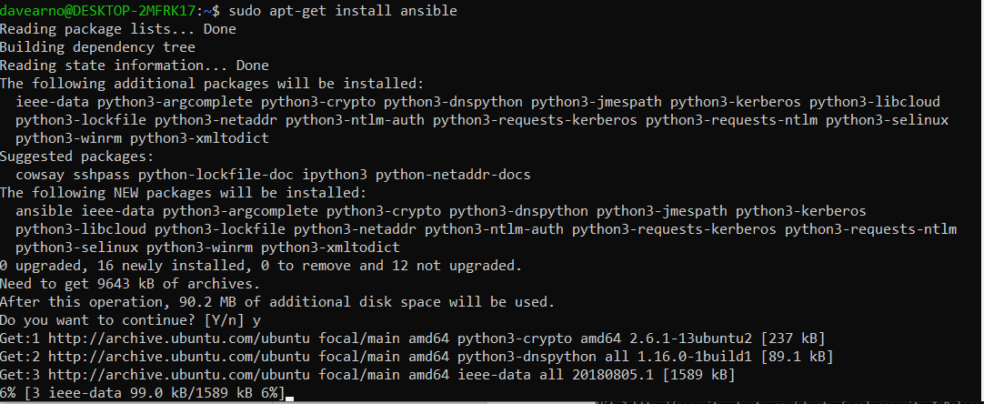

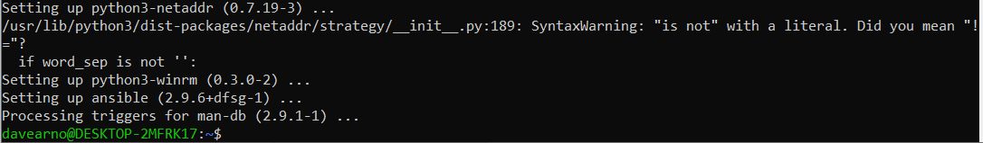

### Check ansible version

**davearno@DESKTOP-2MFRK17:~$ ansible --version**

ansible 2.9.6

config file = /etc/ansible/ansible.cfg

configured module search path = ['/home/davearno/.ansible/plugins/modules', '/usr/share/ansible/plugins/modules']

ansible python module location = /usr/lib/python3/dist-packages/ansible

executable location = /usr/bin/ansible

python version = 3.8.2 (default, Mar 13 2020, 10:14:16) [GCC 9.3.0]

## Get details for an IBM baremetal server

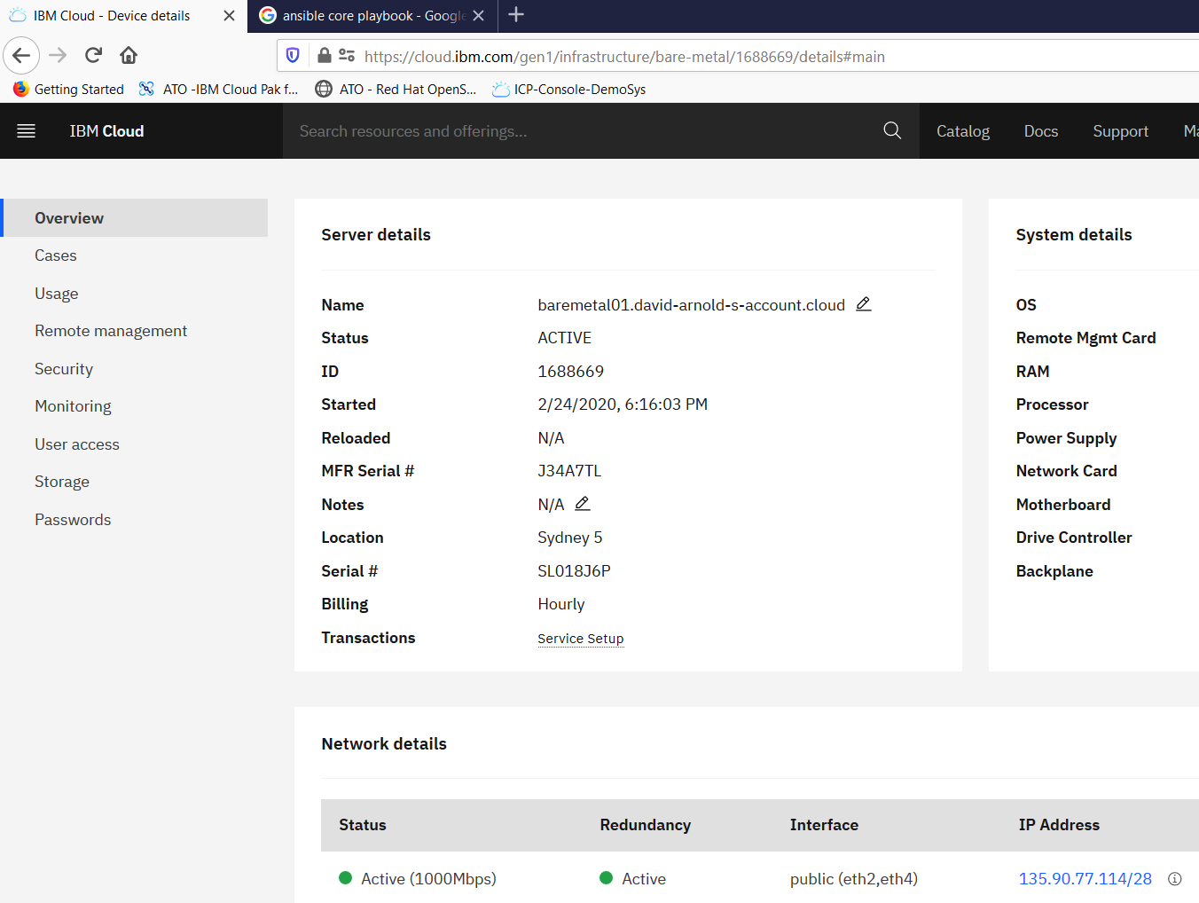

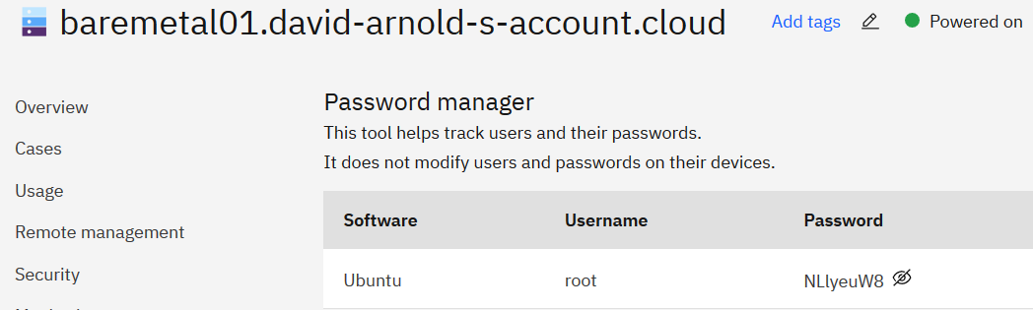

## Test SSH into baremetal server from ubuntu on windows

ssh root@135.90.77.114

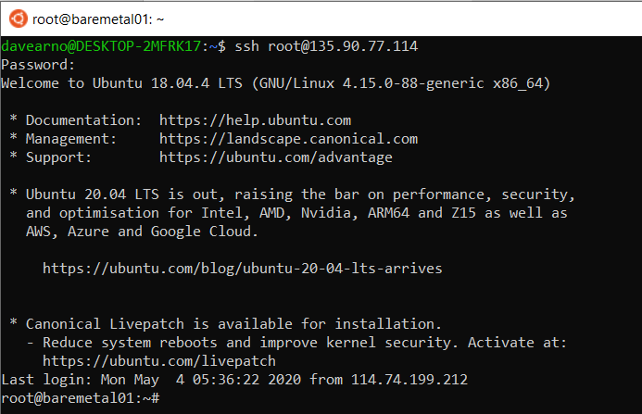

root@baremetal01:~# exit

## Create the inventory file - hosts

davearno@DESKTOP-2MFRK17:~$nano hosts

copy in the following:

[local]

127.0.0.1

[local:vars]

ansible_connection=local

[ibmbaremetal]

135.90.77.114

[ibmbaremetal:vars]

ansible_user=root

ansible_password=NLlyeuW8

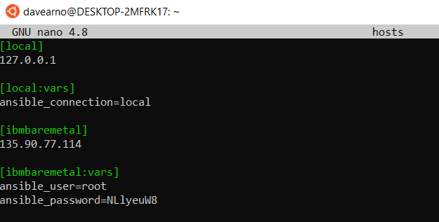

CTRL-O

Enter

CTRL-X

## Install sshpass

Ansible uses SSH. In order to connect to an IBM baremetal server you will need to use a username and password (as specified in the inventory file).

If you try and ping the baremetal server it will fail as follows.

davearno@DESKTOP-2MFRK17:~$ansible -i hosts ibmbaremetal -m ping



davearno@DESKTOP-2MFRK17:~$ su root

root@DESKTOP-2MFRK17:/home/davearno# apt-get install sshpass

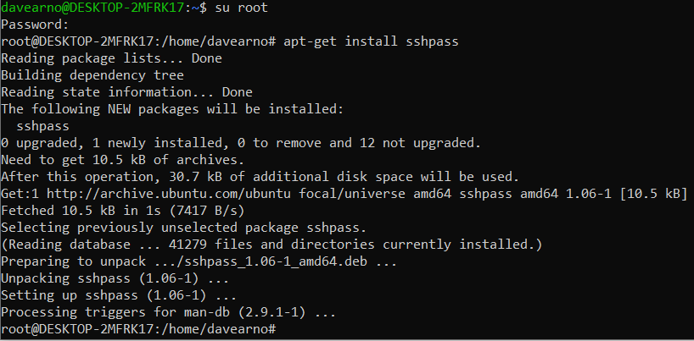

root@DESKTOP-2MFRK17:/home/davearno# su davearno

## Test and ansible command - ping

ansible -i hosts ibmbaremetal -m ping

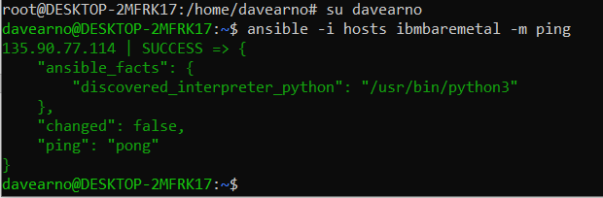

## Create a playbook to test

nano testbook.yml

copy in the following:

- name: testing ansible

hosts: ibmbaremetal

tasks:

- name: echo a message

debug: msg="this is working"

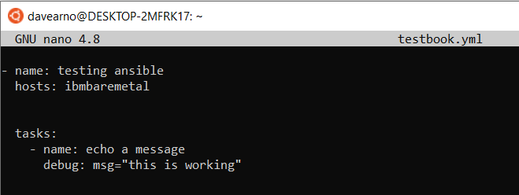

CTRL-O

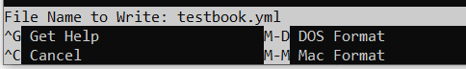

Enter

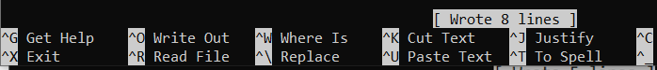

CTRL-X

## Test and ansible playbook

davearno@DESKTOP-2MFRK17:~$ ansible-playbook -i hosts testbook.yml

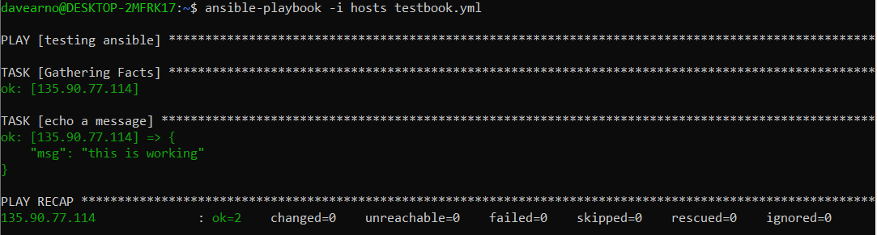

## Set up ansible.cfg file

davearno@DESKTOP-2MFRK17:~$ cat /etc/ansible/ansible.cfg

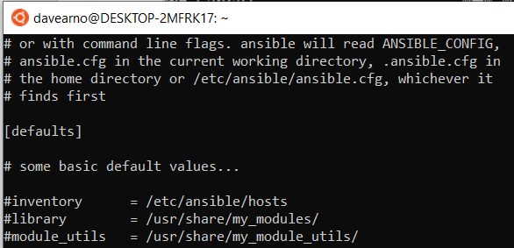

su root

root@DESKTOP-2MFRK17:/home/davearno# nano /etc/ansible/ansible.cfg

[defaults]  
inventory = ./hosts

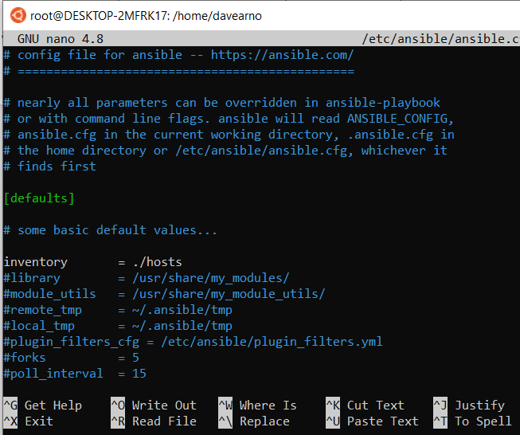

root@DESKTOP-2MFRK17:/home/davearno# su davearno

### Retest playbook without -i

davearno@DESKTOP-2MFRK17:~$ ansible-playbook testbook.yml

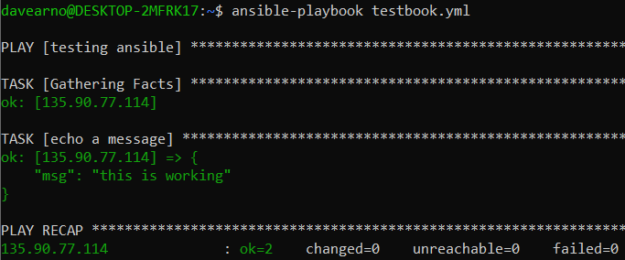

## Run a linux command on the bare metal server

### From the command line

davearno@DESKTOP-2MFRK17:~$ ansible ibmbaremetal -m command -a "ls"

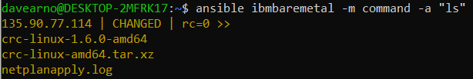

### Create a playbook to run a linux command

davearno@DESKTOP-2MFRK17:~$ nano list.yml

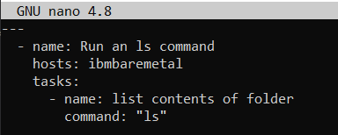

davearno@DESKTOP-2MFRK17:~$ ansible-playbook list.yml

## Run a command to create a file on the bare metal server

### From the command line

ansible ibmbaremetal -a "touch /tmp/testfile creates=/tmp/testfile"



### Create a playbook to create, display and remove a file on baremetal

Three tasks

* First one is a create a file if it does not exist
* Second to display if the creation is successful
* Third one is to delete the file if it exists

davearno@DESKTOP-2MFRK17:~$ nano createfile.yml

---

- name: "Validate if a file is present or not present using Ansible Command module"

hosts: ibmbaremetal

tasks:

- name: "Create a file if it does not exist"

command: "touch /tmp/latestfile"

args:

creates: "/tmp/latestfile"

register: createif

- name: "Display the file to make sure its created"

command: "ls -lrt /tmp/latestfile"

register: displayif

when: createif is changed

- debug: var=displayif.stdout

- name: "Remove the file if it exist"

command: "rm -rf /tmp/latestfile"

args:

removes: "/tmp/latestfile"

register: removeif

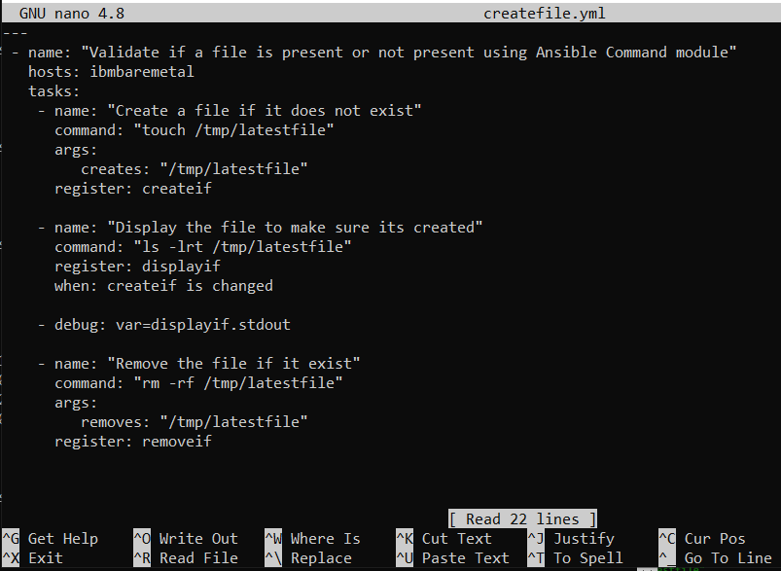

davearno@DESKTOP-2MFRK17:~$ ansible-playbook createfile.yml

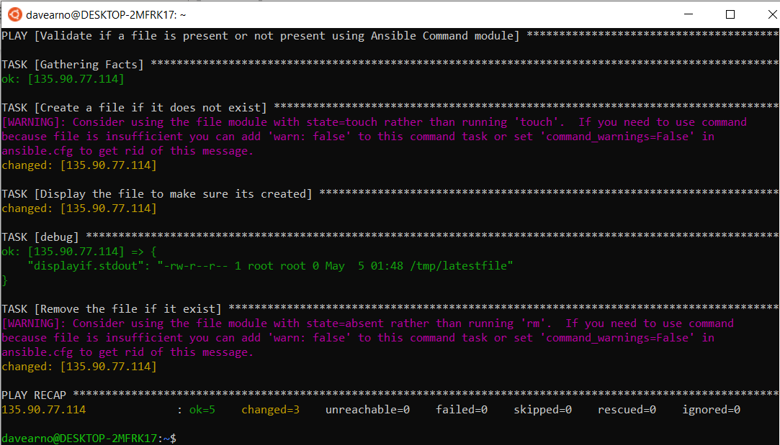

### Modify ansible.cfg to remove command warnings

[WARNING]: Consider using the file module with state=absent rather than running 'rm'. If you need to use command

because file is insufficient you can add 'warn: false' to this command task or set 'command_warnings=False' in

ansible.cfg to get rid of this message.

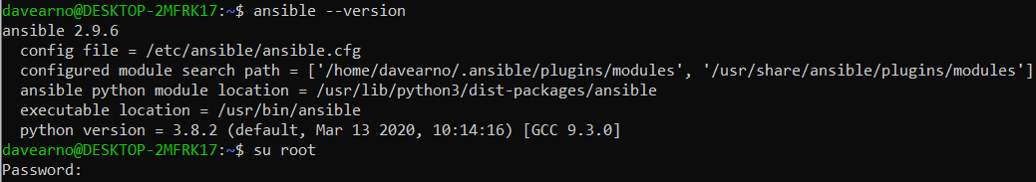

root@DESKTOP-2MFRK17:/home/davearno# nano /etc/ansible/ansible.cfg

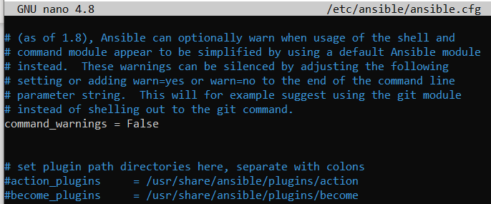

root@DESKTOP-2MFRK17:/home/davearno# su davearno

### Re-run the playbook

davearno@DESKTOP-2MFRK17:~$ ansible-playbook createfile.yml

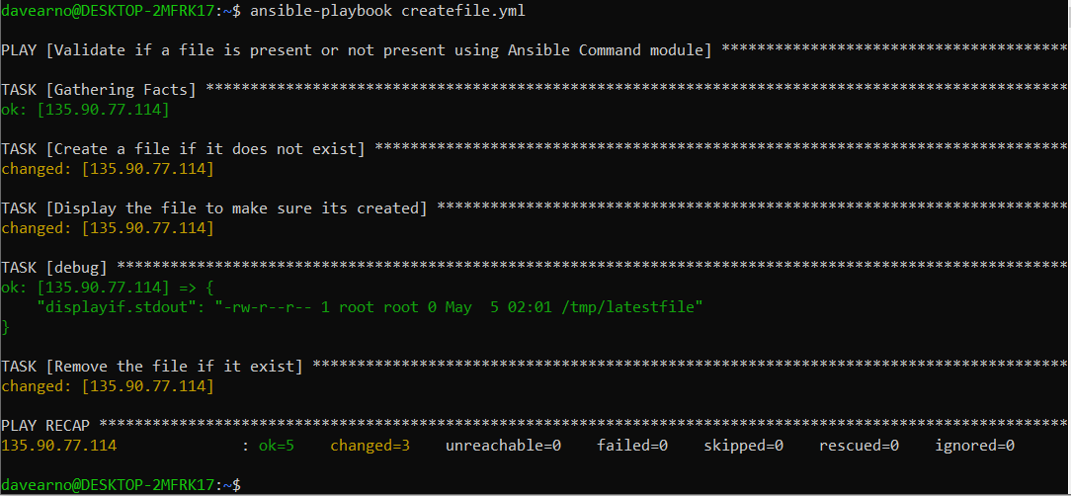

## Install a Test MQ system on baremetal

### SSH into baremetal server from ubuntu on windows

ssh [root@135.90.77.114](mailto:root@135.90.77.114)

password: NLlyeuW8

A second user on the server is arnold/(dNpengxx)

### Set up for MQ Install

sudo adduser mqm

password:passw0rd

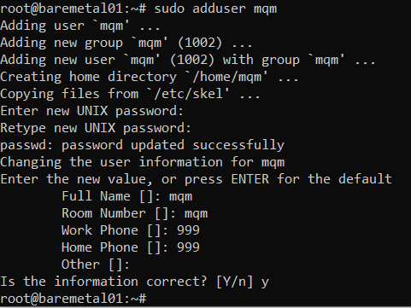

groups mqm

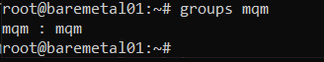

### Download MQ

<https://developer.ibm.com/messaging/mq-downloads/>

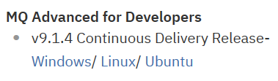

Click on ubuntu

Get the URL from your browser

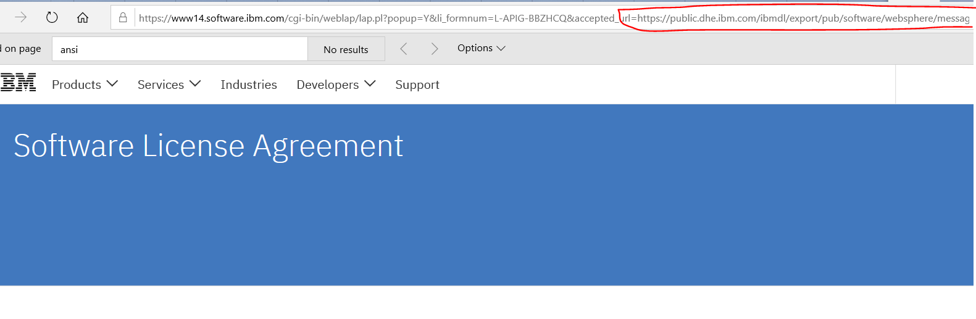

<https://public.dhe.ibm.com/ibmdl/export/pub/software/websphere/messaging/mqadv/mqadv_dev914_ubu>

download the tar zip to the server

**root@baremetal01:~# wget** [**https://public.dhe.ibm.com/ibmdl/export/pub/software/websphere/messaging/mqadv/mqadv_dev914_ubuntu_x86-64.tar.gz**](https://public.dhe.ibm.com/ibmdl/export/pub/software/websphere/messaging/mqadv/mqadv_dev914_ubuntu_x86-64.tar.gz)

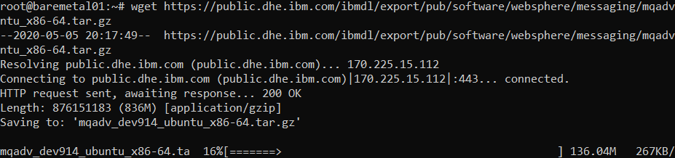

### Install supporting packages

sudo apt install rpm

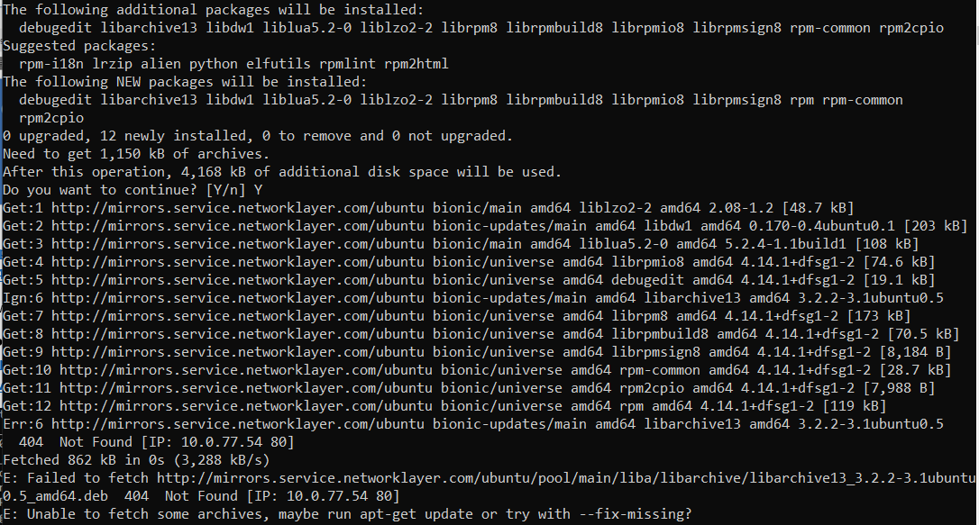

sudo apt-get update

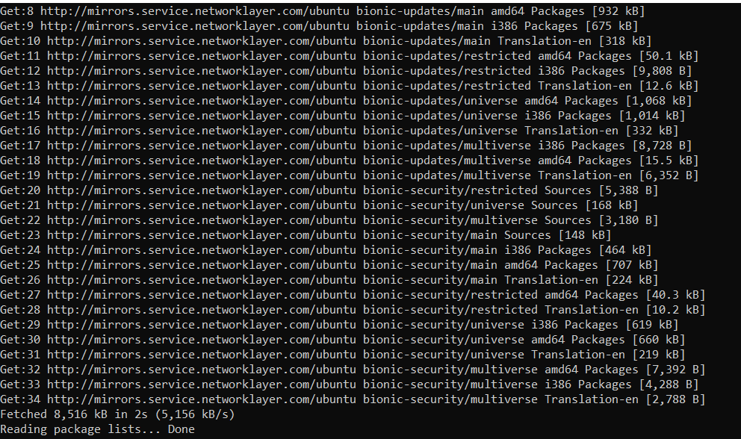

sudo apt-get update -y

sudo apt-get install -y pax

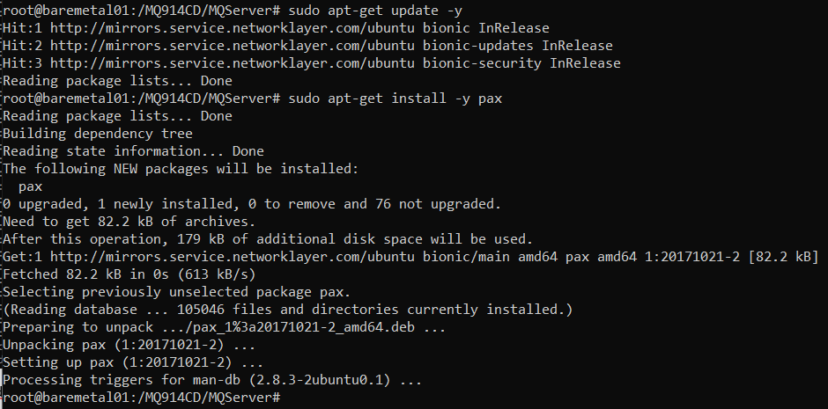

sudo apt-get install -y rpm

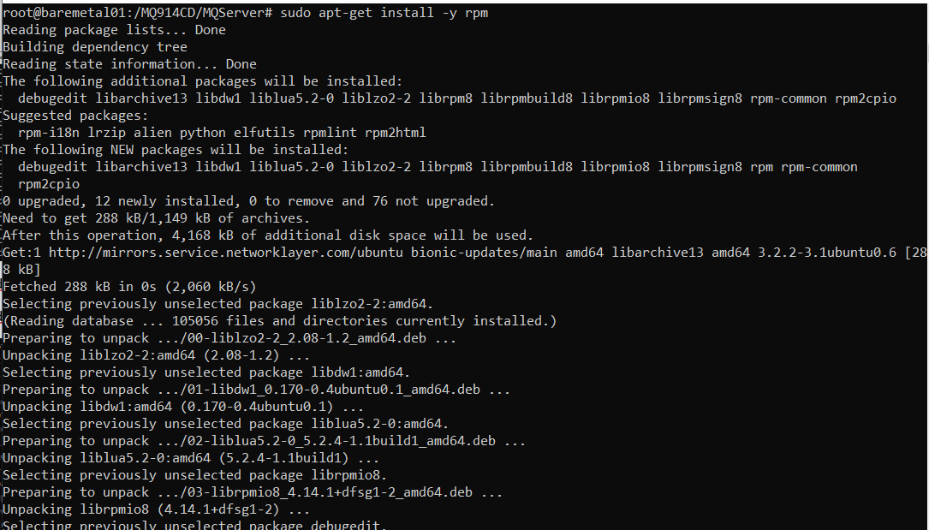

### Check the mqm user

getent passwd | grep mqm



### Unpack MQ and accept the license

mkdir /MQ914CD

tar -xzf mqadv_dev914_ubuntu_x86-64.tar.gz -C /MQ914CD

cd /MQ914CD

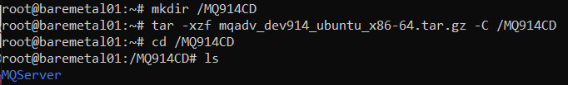

Cd MQServer

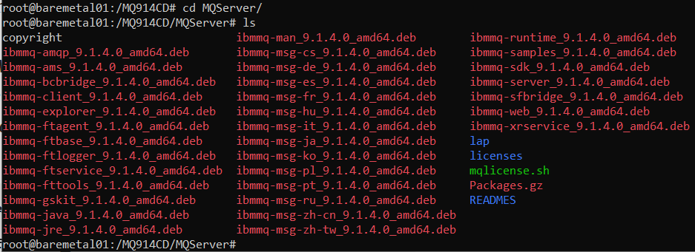

sudo ./mqlicense.sh -text_only

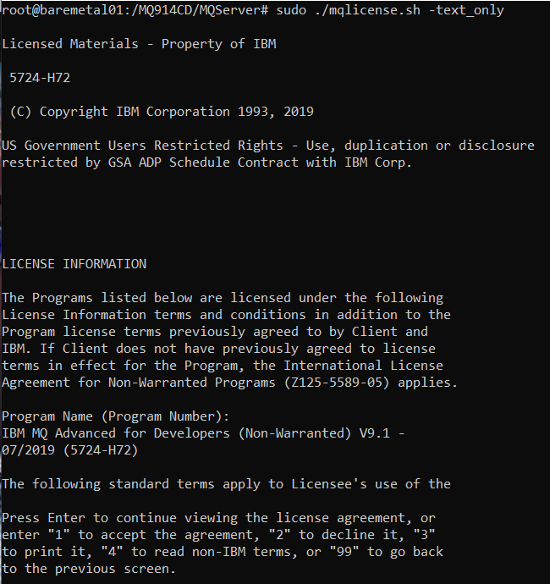

1

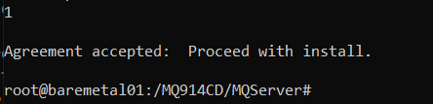

### Debian install of MQ

nano /etc/apt/sources.list.d/IBM_MQ.list

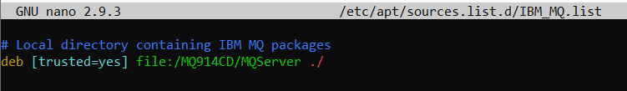

apt install /MQ914CD/MQServer/ibmmq-*

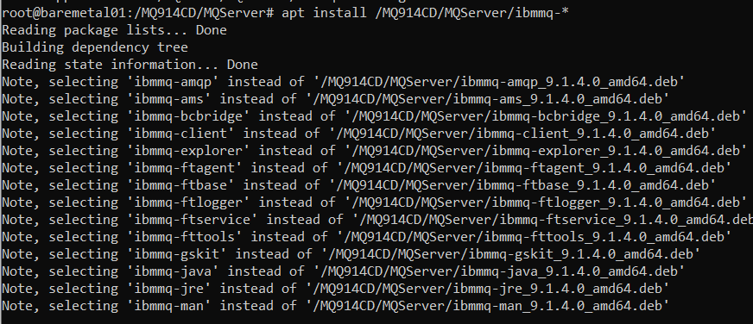

### Check install logs

cat /tmp/mqconfig.14827.log

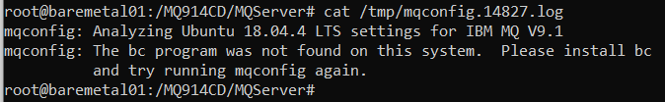

### Install bc

apt install yum

apt install bc

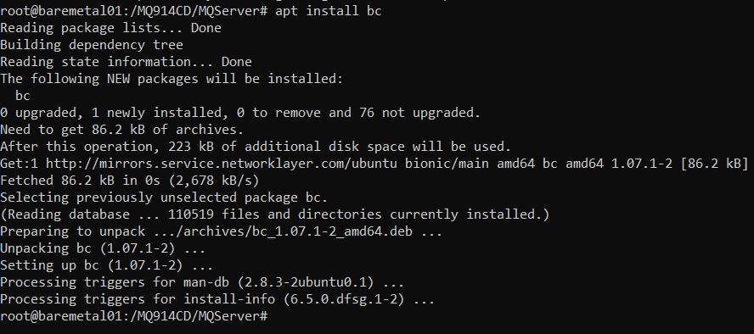

### Check the MQconfig

/opt/mqm/bin/mqconfig

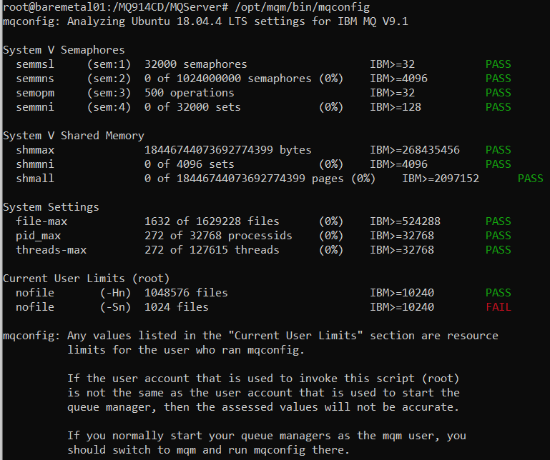

### Set up current user limits

Su mqm

/opt/mqm/bin/mqconfig

Su root

nano /etc/security/limits.conf

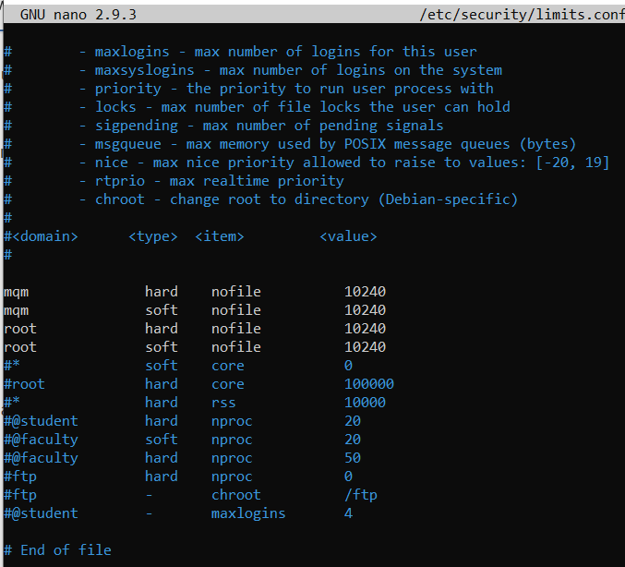

/opt/mqm/bin/mqconfig

Su mqm

/opt/mqm/bin/mqconfig

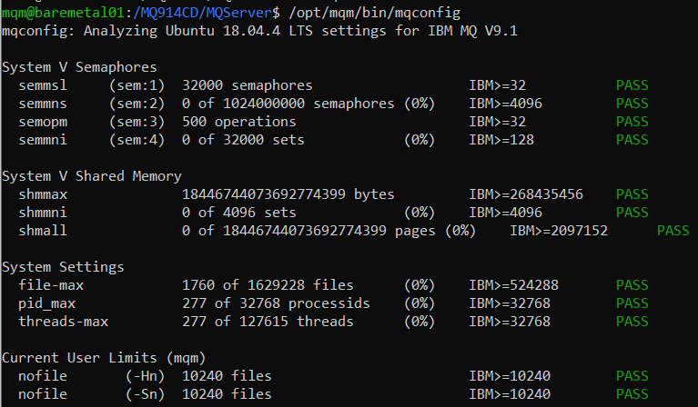

### Create a queue manager

/opt/mqm/bin/crtmqm mytektqmgr

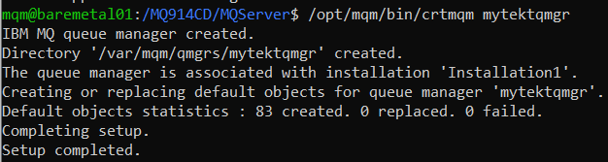

### Start the queue manager

/opt/mqm/bin/strmqm mytektqmgr

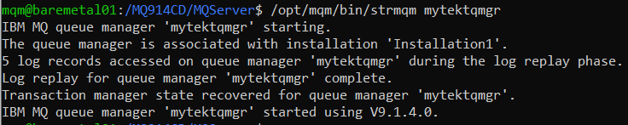

### Configure the queue manager for remote connection

/opt/mqm/bin/runmqsc mytektqmgr

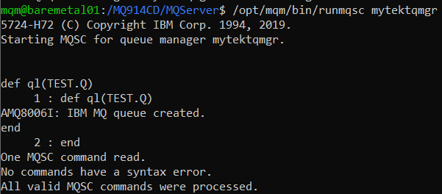

### Create an MQSC file to enable remote (client) administration

nano /tmp/NOTLSSRVCONN.mqsc

copy and paste

DEFINE CHANNEL(IVT.SVRCONN) CHLTYPE(SVRCONN)

SET CHLAUTH(IVT.SVRCONN) TYPE(BLOCKUSER) USERLIST(nobody)

ALTER AUTHINFO(SYSTEM.DEFAULT.AUTHINFO.IDPWOS) AUTHTYPE(IDPWOS) CHCKCLNT(NONE) ADOPTCTX(YES)

SET CHLAUTH(IVT.SVRCONN) TYPE (ADDRESSMAP) ADDRESS(*) MCAUSER('mqm')

REFRESH SECURITY TYPE(CONNAUTH)

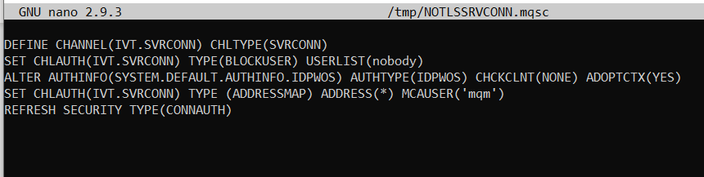

/opt/mqm/bin/runmqsc mytektqmgr < /tmp/NOTLSSRVCONN.mqsc

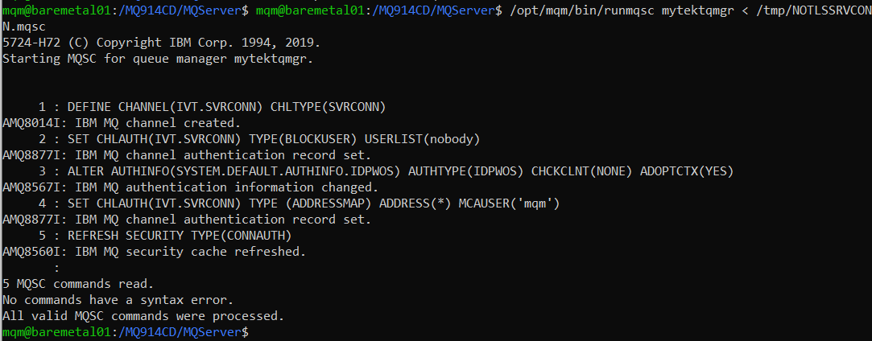

### Define and start a listener

/opt/mqm/bin/runmqsc mytektqmgr

DEF LISTENER(LISTENER.TCP) TRPTYPE(TCP) CONTROL(QMGR) PORT(1414)

START LISTENER(LISTENER.TCP)

DIS LSSTATUS(LISTENER.TCP)

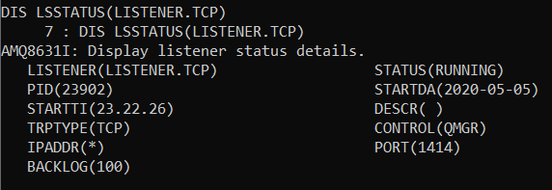

## Create an mqsc file for Ansible to run

nano /tmp/daAnisble.mqsc

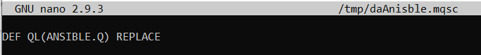



### Local test of mqsc

/opt/mqm/bin/runmqsc mytektqmgr < /tmp/daAnisble.mqsc

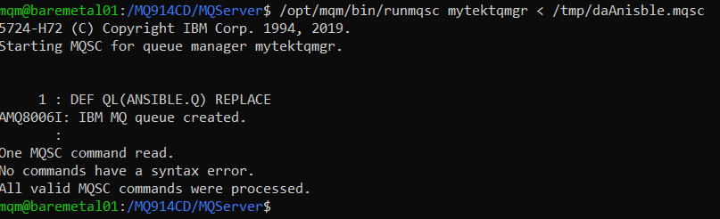

### Create a shell script to run the command

nano /tmp/mqscAnsible.sh

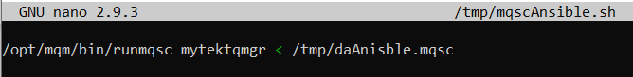

## Connect MQ Explorer

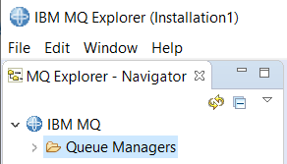

Add a remote queue manager

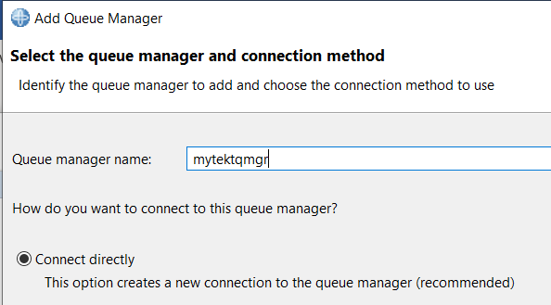

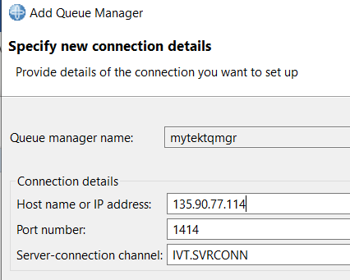

Hit OK

### Review the queues on mytektqmgr

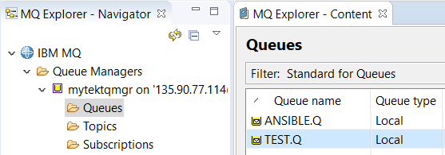

### Delete the ANSIBLE.Q

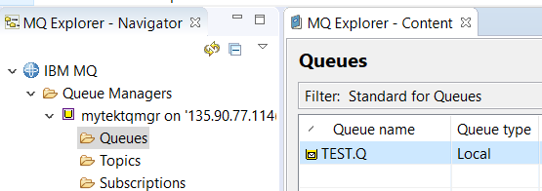

## Using Ansible to administer the MQ queue manager

### Using command line with the ansible RAW module

**Change the ansible_user**

ansible_user=root

ansible_password=NLlyeuW8

ansible_user=mqm

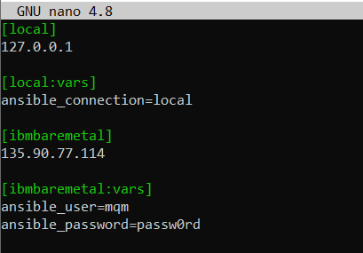ansible_password=passw0rd

davearno@DESKTOP-2MFRK17:~$ ansible ibmbaremetal -m raw -a "/opt/mqm/bin/runmqsc mytektqmgr < /tmp/daAnisble.mqsc"

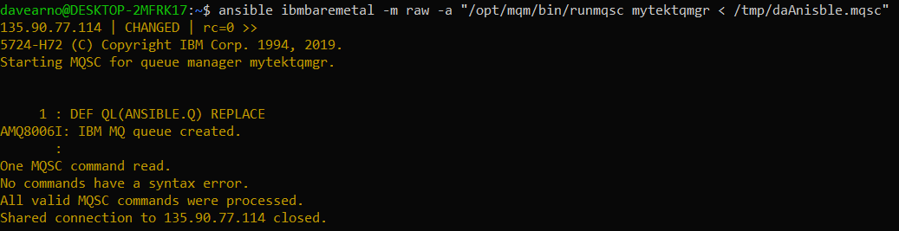

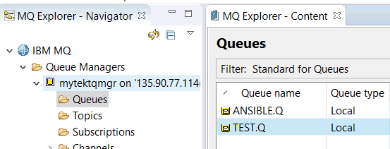

### Using a basic playbook with RAW module

Delete the ANSIBLE.Q in MQ explorer

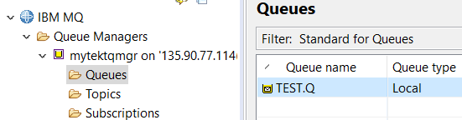

Create a run book.

nano runmqscbook.yml

---

- name: "Execute a runmqsc command piping in a file"

hosts: ibmbaremetal

tasks:

- name: "runmqsc qmgrname < configfile.mqsc"

raw: "/opt/mqm/bin/runmqsc mytektqmgr < /tmp/daAnisble.mqsc"

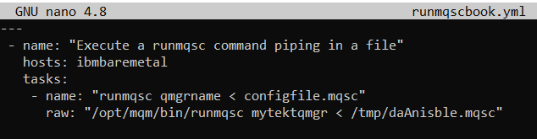

davearno@DESKTOP-2MFRK17:~$ ansible-playbook runmqscbook.yml

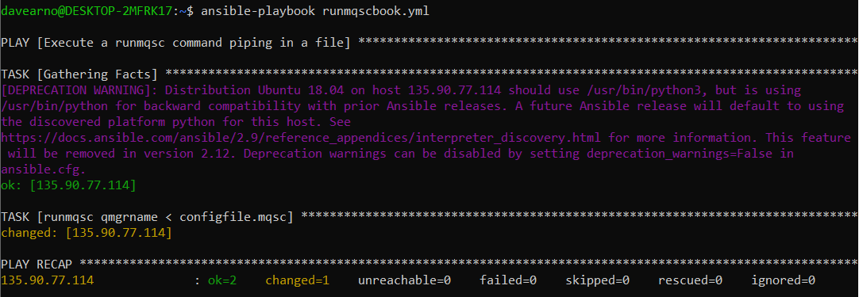

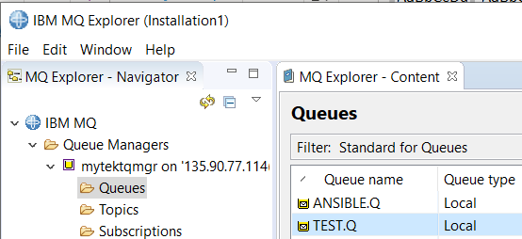

# Exploring Ansible with Kubernetes

## References to Tekton and MQ on RH Openshift

As I explore the use of Ansible with Kubernetes I will be targeting a RedHat OpenShift cluster I have running on the IBM Cloud ROKS service. In this cluster I have set up Tekton pipelines to build and deploy IBM MQ images. Later in this section I will use Ansible to interact with MQ deployments and kick off Tekton pipelines. The work I have done with Tekton and MQ on RH Openshift is captured in these github repositories.

<https://github.com/DAVEXACOM/tekton-mq-example>

<https://github.com/DAVEXACOM/ibm-mqadvanced-server-tls-tekton>

### Documentation

https://github.com/DAVEXACOM/tekton-mq-example/tree/master/doc

## Install Kubectl and OC clients on Baremetal server

### Download and install the Kubectl client

C:\Users\DAVIDARNOLD>ssh root@135.90.77.114

Password:

Welcome to Ubuntu 18.04.4 LTS (GNU/Linux 4.15.0-88-generic x86_64)

curl -LO https://storage.googleapis.com/kubernetes-release/release/`curl -s [https://storage.googleapis.com/kubernetes-release/release/stable.txt`/bin/linux/amd64/kubectl](https://storage.googleapis.com/kubernetes-release/release/stable.txt%60/bin/linux/amd64/kubectl)

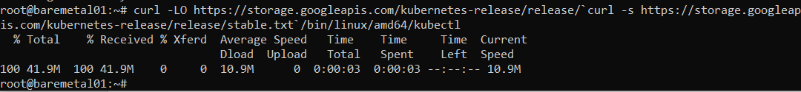

Make the kubectl binary executable.

chmod +x ./kubectl

Move the binary in to your PATH.

sudo mv ./kubectl /usr/local/bin/kubectl

Test to ensure the version you installed is up-to-date:

kubectl version --client



### Download and install the OC client

wget <https://mirror.openshift.com/pub/openshift-v4/clients/ocp/latest/openshift-client-linux.tar.gz>

tar xvzf openshift*.tar.gz

sudo mv oc kubectl /usr/local/bin/

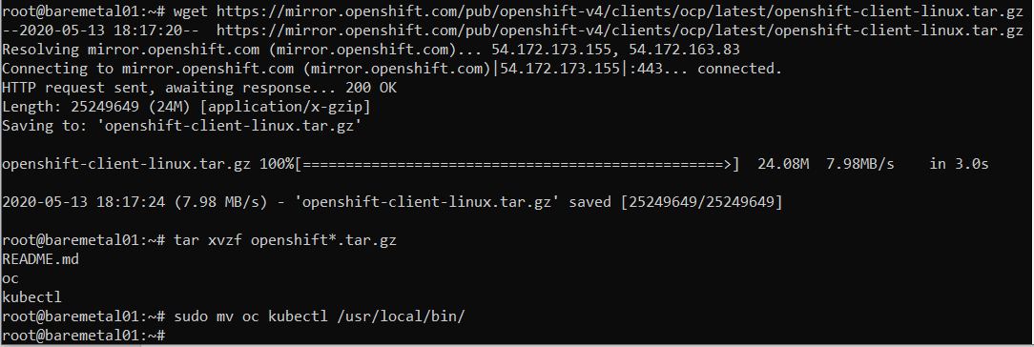

## Test connection to cluster manually from Baremetal server

### Get the K8s cluster token

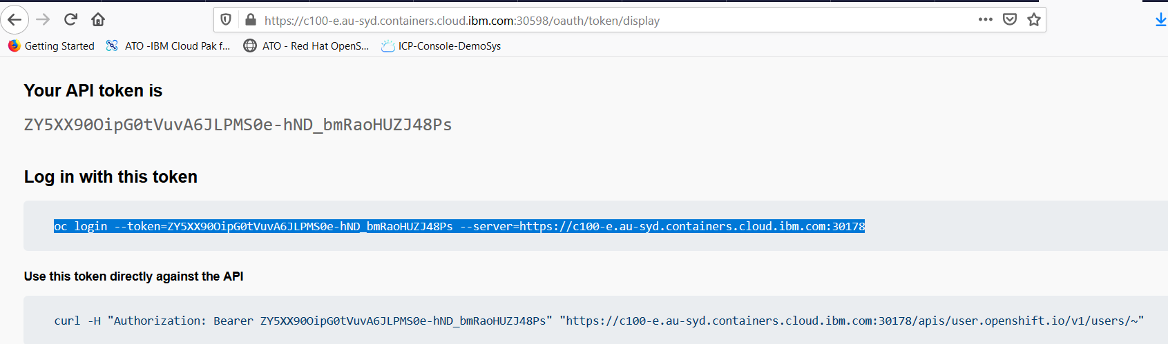

### Test OC client

oc login --token=H00RtQr0G-xtf4uvT8mdHcv59PbKExf0aeMld6Aj0gw --server=https://c100-e.au-syd.containers.cloud.ibm.com:30178

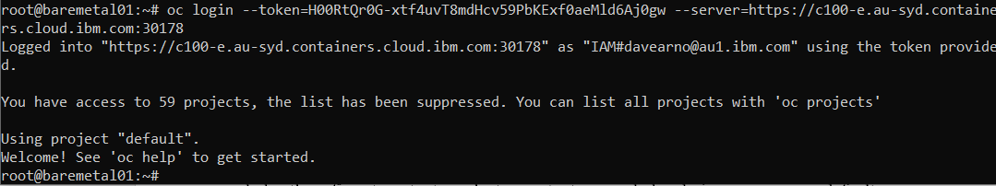

root@baremetal01:~# oc project da-build-project

root@baremetal01:~# oc get pods

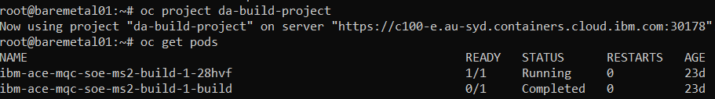

### Test Kubectl client

kubectl config set-cluster dacluster --server=https://c100-e.au-syd.containers.cloud.ibm.com:30178 --insecure-skip-tls-verify=true

kubectl config set-context mycluster-context --cluster=dacluster

kubectl config set-credentials kubeadmin --token=H00RtQr0G-xtf4uvT8mdHcv59PbKExf0aeMld6Aj0gw

kubectl config set-context mycluster-context --user=kubeadmin --namespace=default

kubectl config use-context mycluster-context

kubectl config set-context --current --namespace=da-build-project



Kubectl get pods

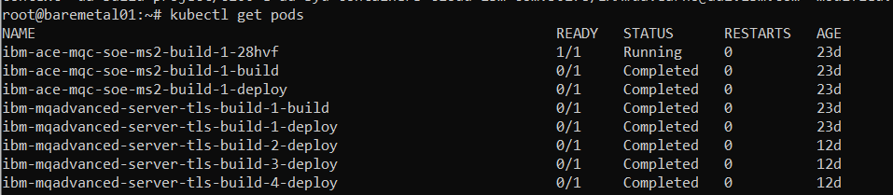

## Using SSH to run kubectl/oc commands

Testing without using the Ansible Kubernetes plugin as a direct alternative protocol to SSH

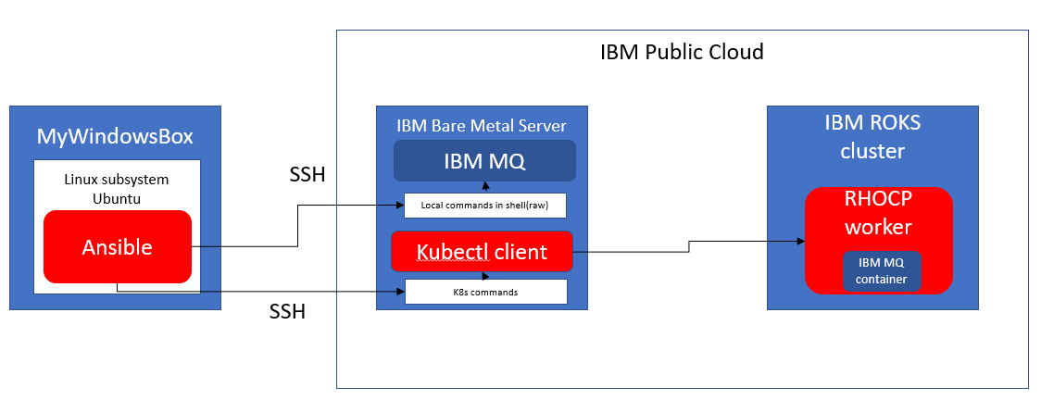

### Using Ansible command line

Kubectl was installed under root user on baremetal server so update the hosts file with nano

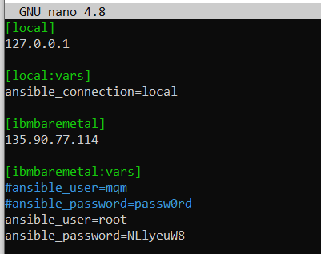

davearno@DESKTOP-2MFRK17:~$ ansible ibmbaremetal -m raw -a " kubectl get pods"

note that the command is picking up the “last” connection and namespace context that was set with kubectl manually on the baremetal server

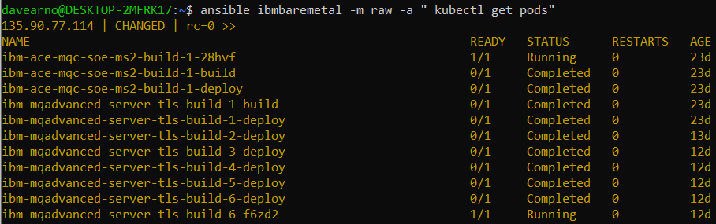

Overriding namespace context is possible

davearno@DESKTOP-2MFRK17:~$ ansible ibmbaremetal -m raw -a " kubectl get pods --namespace default"



### Create a pipeline run YAML on baremetal server

root@baremetal01:~# nano mqtls-buildah-pipelinerun.yaml

and copy in:

apiVersion: tekton.dev/v1alpha1

kind: PipelineRun

metadata:

generateName: mqtls-pr-bahdep-

spec:

pipelineRef:

name: mqtls-build-and-deploy-pipeline-buildah

serviceAccountName: pipeline

resources:

- name: git-source

resourceRef:

name: git-source

params:

- name: qmgrName

value: datektqmgrx

- name: pathToYamlFile

value: "mqdeploymentconfig/ibmmq.yaml"

- name: pathToContext

value: ./

- name: imageUrl

value: image-registry.openshift-image-registry.svc:5000/da-build-project/ibm-mqadvanced-server-tls-build

- name: imageTag

value: "latest"

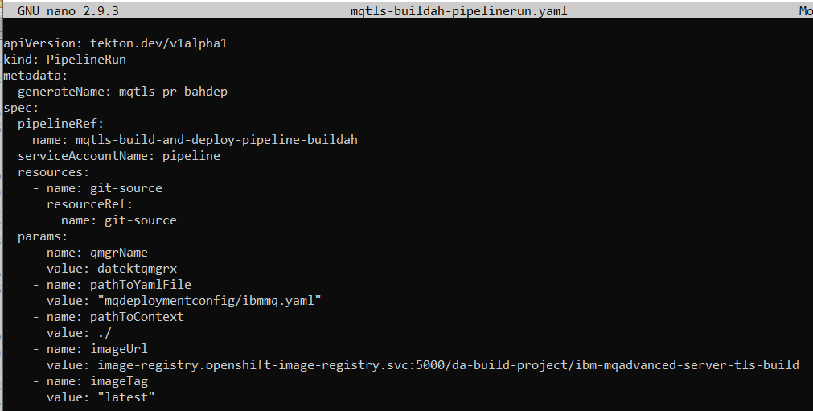

### Use ansible command line to kick off the pipeline from Linux subsystem

ansible ibmbaremetal -m raw -a "oc create -f mqtls-buildah-pipelinerun.yaml

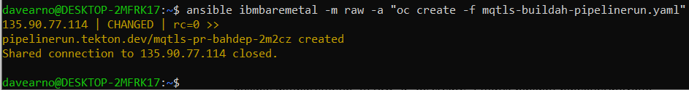

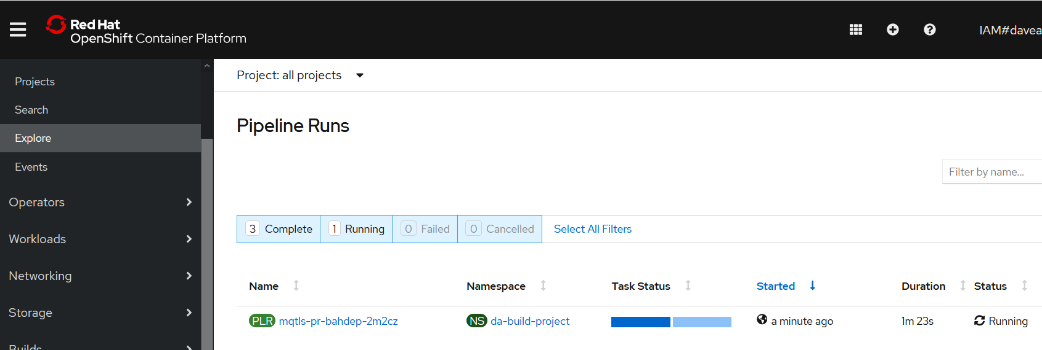



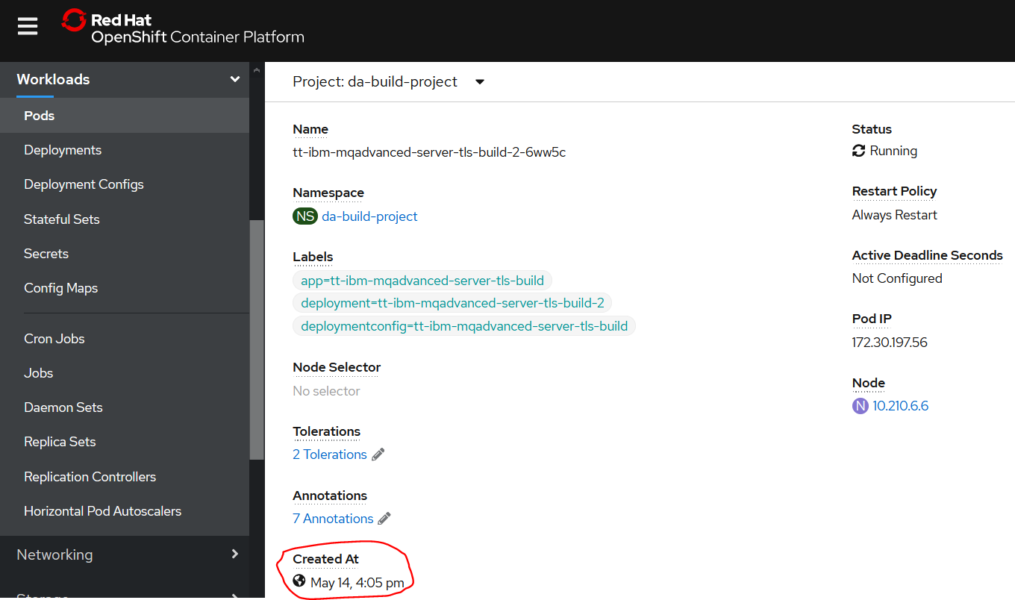

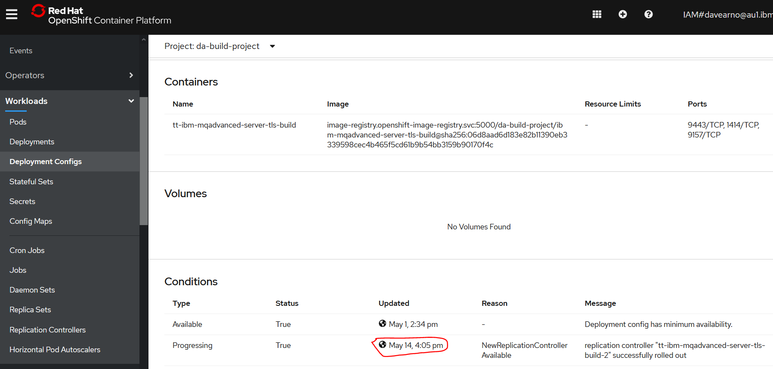

## Using the Ansible K8s connection plugin on Linux subsystem

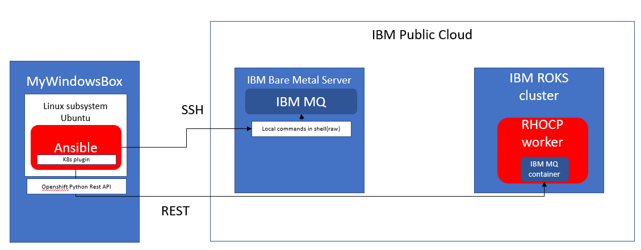

I have problems running ansible against localhost so I will try running ansible against baremetal to get the job done.

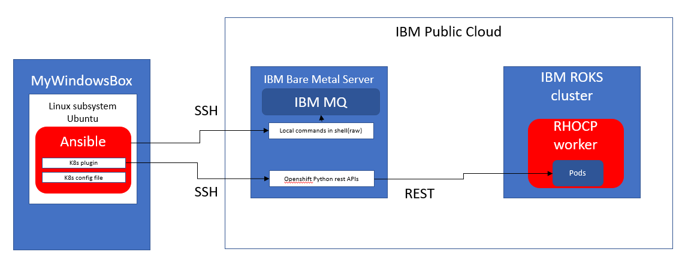

### Install the K8s connection plugin on Linux subsystem on Windows

ansible-galaxy collection install community.kubernetes



## Test Connectivity to the cluster from Linux subsystem

### Get the cluster login command

oc login --token=CZ72BA2BaJsUSowZqDJ1j7dvcEnJfPK6rf0D2PJZQTw --server=https://c100-e.au-syd.containers.cloud.ibm.com:30178

### Ping the Console from baremetal server



Note the ipaddress 135.90.66.2

### Test OC client from linux subsystem

oc login --token=CZ72BA2BaJsUSowZqDJ1j7dvcEnJfPK6rf0D2PJZQTw --server=https://c100-e.au-syd.containers.cloud.ibm.com:30178

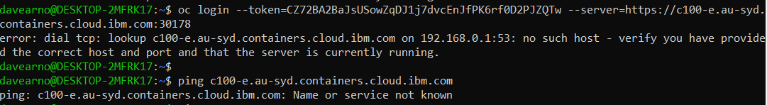

Try it with the 135.90.66.2 address

oc login --token=CZ72BA2BaJsUSowZqDJ1j7dvcEnJfPK6rf0D2PJZQTw --server=https://135.90.66.2:30

178

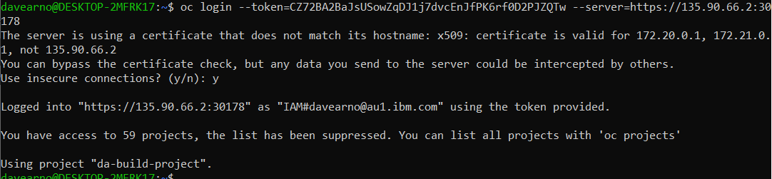

oc get pods

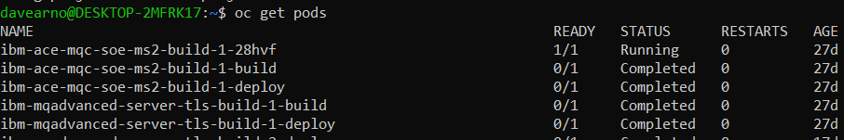

### Test Kubectl client

kubectl config set-cluster dacluster --server=https://135.90.66.2:30178 --insecure-skip-tls-verify=true

kubectl config set-context mycluster-context --cluster=dacluster



kubectl config set-credentials kubeadmin --token=CZ72BA2BaJsUSowZqDJ1j7dvcEnJfPK6rf0D2PJZQTw

kubectl config set-context mycluster-context --user=kubeadmin --namespace=default

kubectl config use-context mycluster-context

kubectl config set-context --current --namespace=da-build-project

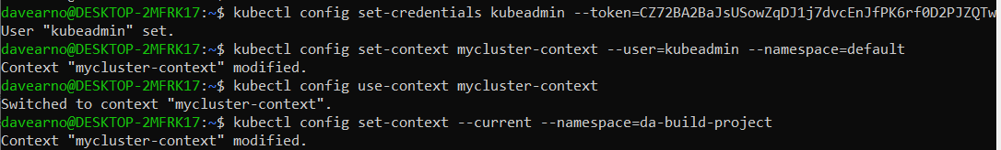

kubectl get pods

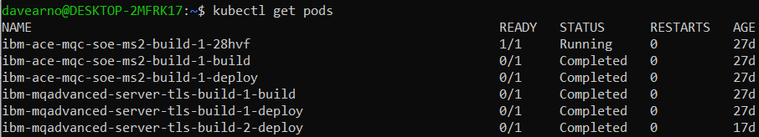

## Set up Ansible for k8s connection plugin

### Useful links

Use the kubectl exec command to run tasks in, or put/fetch files to, pods running on the Kubernetes container platform

https://docs.ansible.com/ansible/latest/plugins/connection/kubectl.html

<https://stackoverflow.com/questions/59718310/how-to-setup-ansible-playbook-that-is-able-to-execute-kubectl-kubernetes-comma>

### K8s inventory source – k8s.yml

From examples at: <https://docs.ansible.com/ansible/latest/plugins/inventory/k8s.html>

There are several ways to do it. Three examples here

*# File must be named k8s.yaml or k8s.yml*

*# Authenticate with token, and return all pods and services for all namespaces*

plugin**:** k8s

connections**:**

**-** host**:** https://192.168.64.4:8443

token**:** xxxxxxxxxxxxxxxx

validate_certs**:** false

*# Use default config (~/.kube/config) file and active context, and return objects for a specific namespace*

plugin**:** k8s

connections**:**

**-** namespaces**:**

**-** testing

*# Use a custom config file, and a specific context.*

plugin**:** k8s

connections**:**

**-** kubeconfig**:** /path/to/config

context**:** 'awx/192-168-64-4:8443/developer'

### K8s.yml file config

*# Authenticate with token, and return all pods and services for all namespaces*

plugin: k8s

connections:

- host: https://135.90.66.2:30178

token: CZ72BA2BaJsUSowZqDJ1j7dvcEnJfPK6rf0D2PJZQTw

validate_certs: false

davearno@DESKTOP-2MFRK17:~$ nano k8s.yml

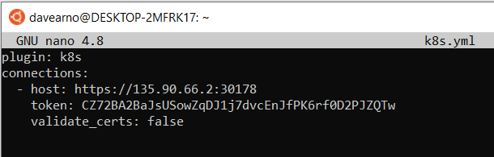

## Write a playbook to test the K8s plugin from linux subsystem

Create a playbook to execute a ps -ef against a pod. Use pod names from an early get pods test

nano psefpods.yml

- hosts: ibmbaremetal

tasks:

- set_fact:

# this is *just an example for brevity*

# in reality you would use `k8s:` or `kubectl get -o name pods -l my-selector=my-value` to get the pod names

pod_names:

- nginx-12345

- nginx-3456

- add_host:

name: '{{ item }}'

groups:

- my-pods

with_items: '{{ pod_names }}'

- hosts: my-pods

connection: kubectl

tasks:

# and now you are off to the races

- command: ps -ef

# watch out if the Pod doesn't have a working python installed

# as you will have to use raw: instead

# (and, of course, disable "gather_facts: no")

- raw: ps -ef

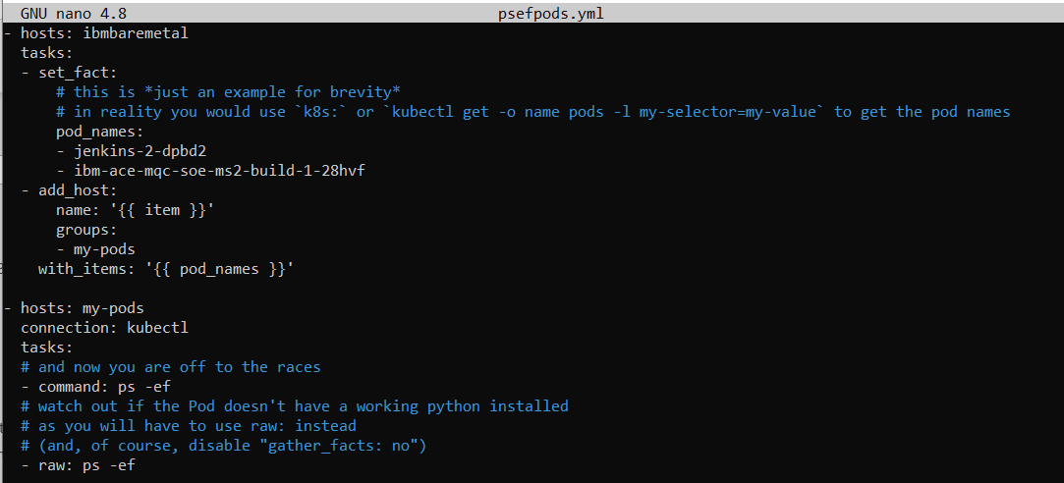

### Run ansible playbook

ansible-playbook psefpods.yml

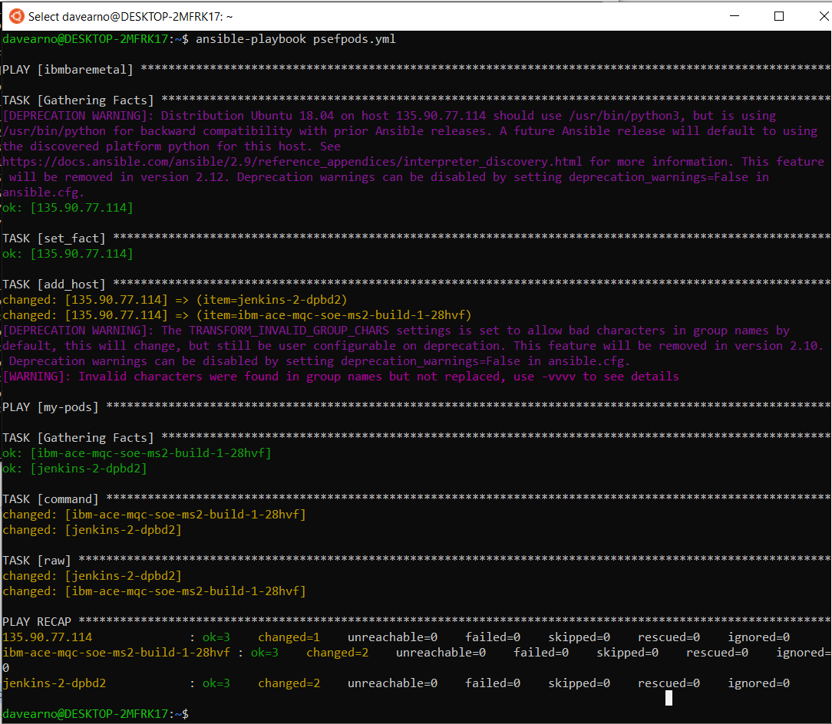

### Reconfigure playbook to run against MQ pod

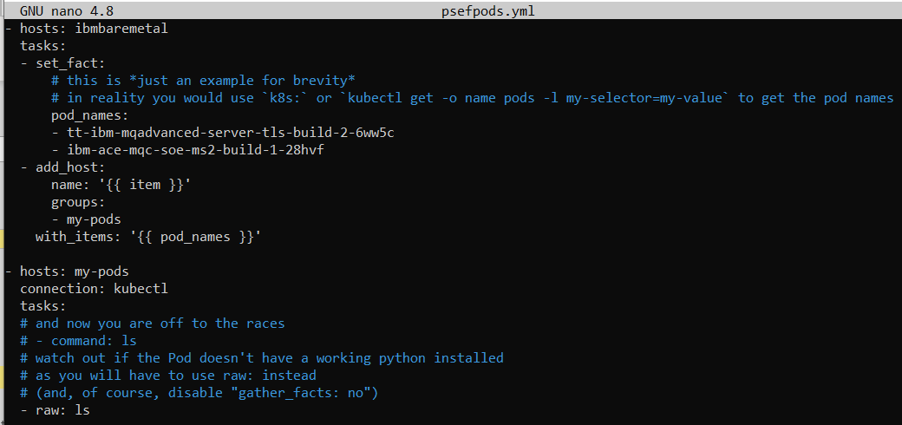

Get this error – unreachable error

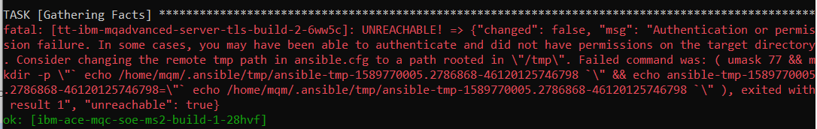

fatal: [tt-ibm-mqadvanced-server-tls-build-2-6ww5c]: UNREACHABLE! => {"changed": false, "msg": "Authentication or permission failure. In some cases, you may have been able to authenticate and did not have permissions on the target directory.

Consider changing the remote tmp path in ansible.cfg to a path rooted in \"/tmp\".

Failed command was: ( umask 77 && mkdir -p \"` echo /home/mqm/.ansible/tmp/ansible-tmp-1589770005.2786868-46120125746798 `\" && echo ansible-tmp-1589770005.2786868-46120125746798=\"` echo /home/mqm/.ansible/tmp/ansible-tmp-1589770005.2786868-46120125746798 `\" ), exited with result 1", "unreachable": true}

Looks like creation of a temporary file is required but we can’t do that with this username in the MQ container (pod) is it is trying to do it in mqm’s home directory

### modify ansible.cfg to fix unreachable error

davearno@DESKTOP-2MFRK17:~$ cat /etc/ansible/ansible.cfg



su root

root@DESKTOP-2MFRK17:/home/davearno# nano /etc/ansible/ansible.cfg

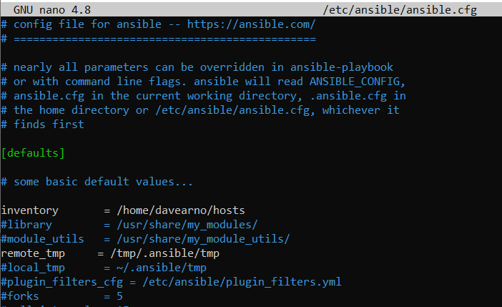

Su davearno

### Rerun the playbook for MQ

ansible-playbook psefpods.yml

now the pod is reachable but our command fails due to no python

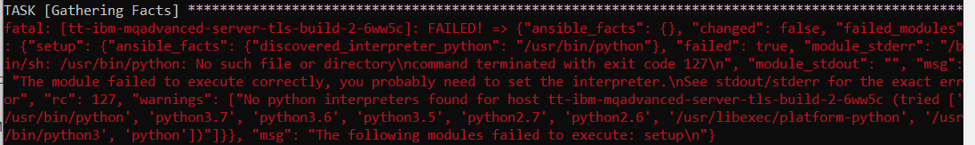

### Turn off gather facts as MQ container has no python

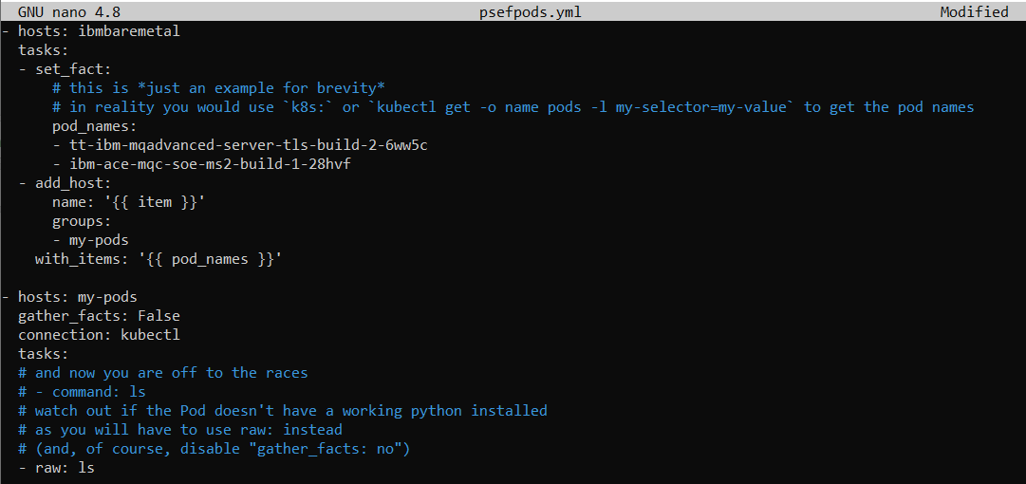

Re-run the playbook

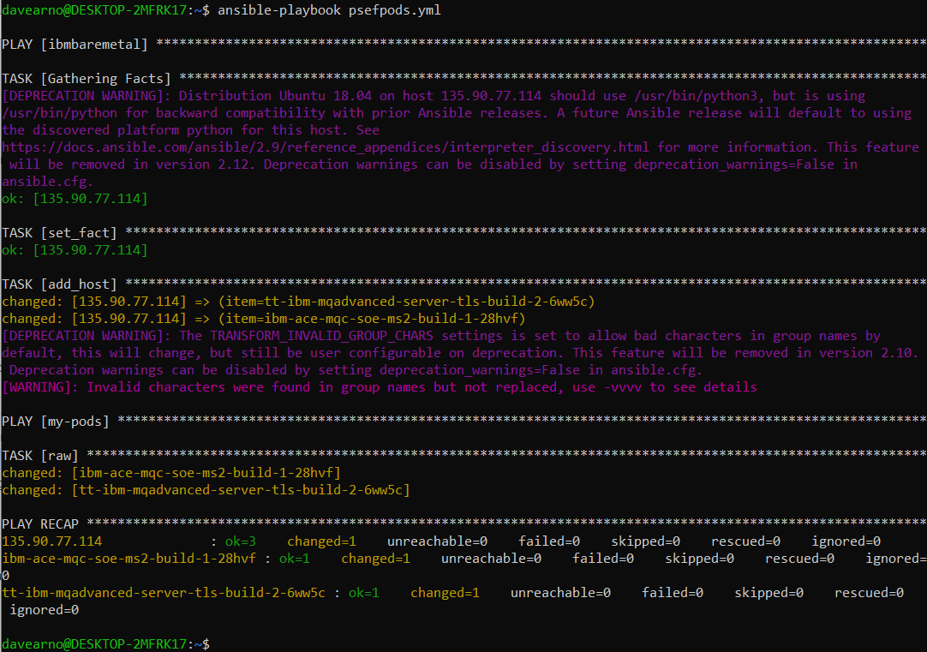

Change the command from “ls” back to “ps -ef”

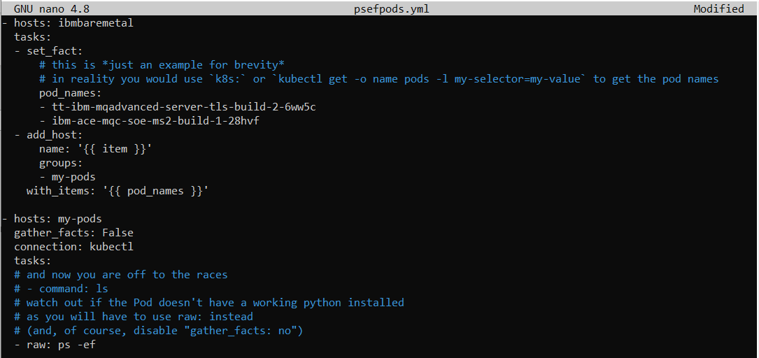

Re-run the playbook

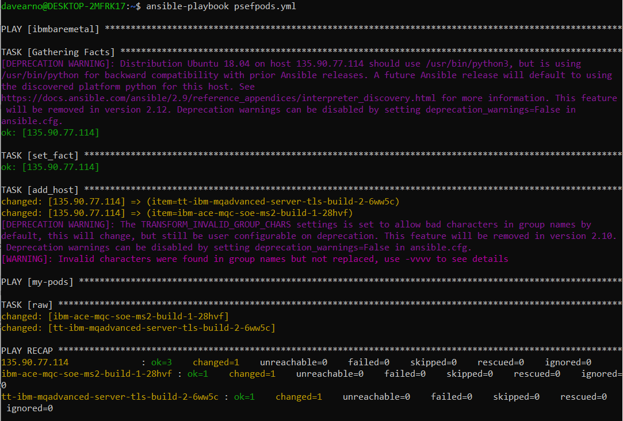

# (re)Configuring MQ with Ansible via Config maps

## Manually investigating Config Maps and Deployment Configs

### Create a config map with an MQSC file

Create a config map where the name is the queue manager name and the MQSC is a simple receiver channel using the naming convention TO.*queuemanagername*

kind: ConfigMap

apiVersion: v1

metadata:

name: mytektqmgr

namespace: da-build-project

data:

example.mqsc: >-

DEFINE CHANNEL(**TO.mytektqmgr**) CHLTYPE(RCVR)

The above contents should be placed in a file <mytektqmgr-cm.yaml> on your local machine

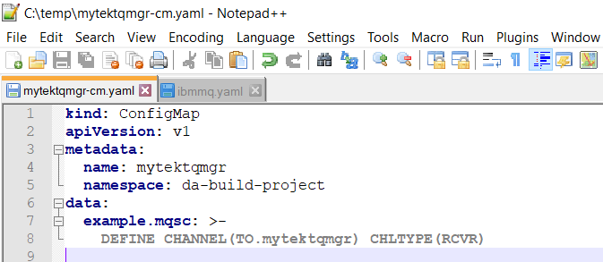

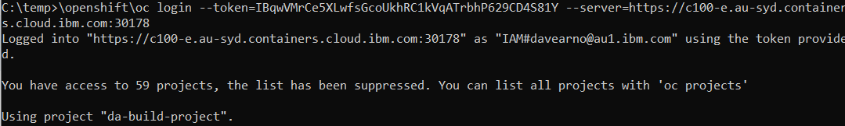

and then use the command:

**oc create -f mytektqmgr-cm.yaml**

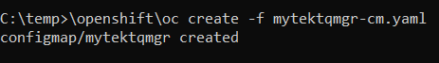

Review in RHOCP Console->workloads->configmaps

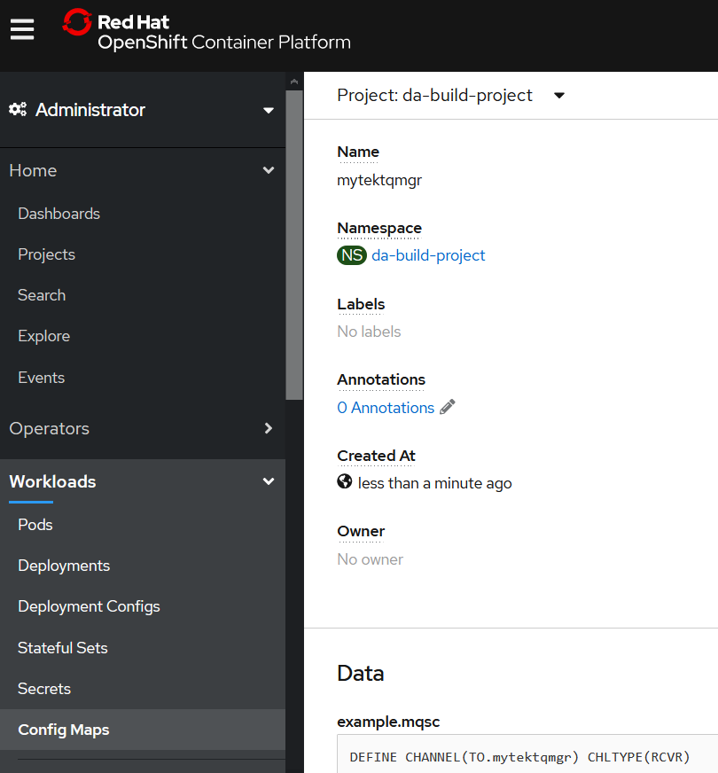

### Some examples of config Maps with volumes – deployment and pod

#### container spec section – Some examples to work from

ref the following for the volume and volume mount for configmap ref container file data we want to place as a file in the container.

<https://opensource.com/article/19/6/introduction-kubernetes-secrets-and-configmaps>

These are the bits we are interested in from the example above deployment (not deployment config) but should be same.

***volumeMounts***:  
***- mountPath*:** /etc/mysql/conf.d  
***name*:** mariadb-config

***volumes***:***- configMap***:***name*:** mariadb-config***items***:***- key*:** max_allowed_packet.cnf***path*:** max_allowed_packet.cnf***name*:** mariadb-config-volume

In the example deployment container spec section

***spec*: *containers*: *- image*: docker.io/mariadb:10.4 *name*: mariadb *env*: *- name*: MYSQL_ROOT_PASSWORD *valueFrom*: *secretKeyRef*: *name*: mariadb-root-password *key*: password *ports*: *- containerPort*: 3306 *protocol*: TCP *volumeMounts*: *- mountPath*: /etc/mysql/conf.d *name*: mariadb-config-volume *volumes*:**

***- configMap*: *name*: mariadb-config *items*: *- key*: max_allowed_packet.cnf *path*: max_allowed_packet.cnf *name*: mariadb-config-volume**

Modifying for MQ it would look something like

***volumeMounts*: *- mountPath*: /etc/mqm/example.mqsc *name*: mq-config-volume *volumes*:**

***- configMap*: *name*: mytektqmgr *items*: *- key*: example.mqsc *path*: example.mqsc *name*: mq-config-volume**

Another good example but for a Pod (not a deployment config)

<https://carlos.mendible.com/2019/02/10/kubernetes-mount-file-pod-with-configmap/>

**ConfigMap**, creating a new **config.yaml** with your custom values:

apiVersion: v1

kind: ConfigMap

metadata:

name: sherlock-config

namespace: default

data:

config.yaml: |

namespaces:

- default

labels:

- "app"

- "owner"

**Note**: I’m using the name of the file as the **key**.

And then create a pod definition, referencing the **ConfigMap**:

apiVersion: v1

kind: Pod

metadata:

name: kube-sherlock

spec:

serviceAccountName: kube-sherlock

containers:

- name: kube-sherlock

image: cmendibl3/kube-sherlock:0.1

volumeMounts:

- name: config-volume

mountPath: /app/config.yaml

subPath: config.yaml

volumes:

- name: config-volume

configMap:

name: sherlock-config

restartPolicy: Never

**Note**: the volume references the **ConfigMap** (sherlock-config), the volume mount specifies the **mountPath** as the file you want to replace (/app/config.yaml) and the **subPath** property is used to reference the file by key (config.yaml)

apiVersion: v1

kind: DeploymentConfig

metadata:

name: tt-ibm-mqadvanced-server-tls-build

spec:

containers:

- name: tt-ibm-mqadvanced-server-tls-build

image: image-registry.openshift-image-registry.svc:5000/da-build-project/ibm-mqadvanced-server-tls-build@sha256:06d8aad6d183e82b11390eb3339598cec4b465f5cd61b9b54bb3159b90170f4c

volumeMounts:

- name: mq-config-volume

mountPath: /etc/mqm/example.mqsc

subPath: example.mqsc

volumes:

- name: mq-config-volume

configMap:

name: mytektqmgr

So Volumes at the same level as containers.

Volumemounts same as image, ports, env – **should it be in the resources section?**

**Example: apparently after and at same level as resource{}**

<https://github.com/weepee-org/openshift-example-project/blob/master/memsql-master/DeploymentConfig.yaml>

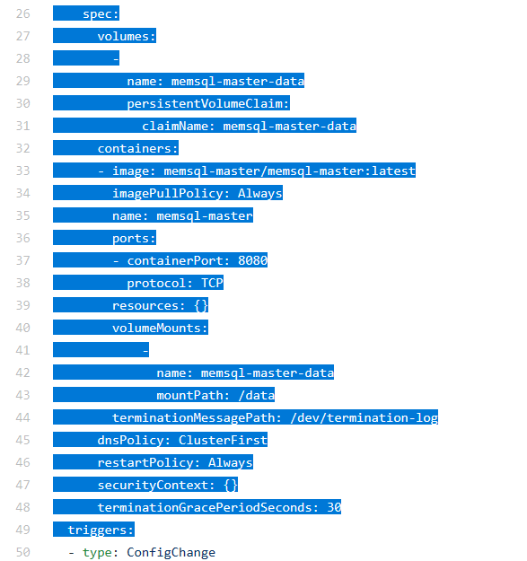

### Modify an MQ deployment config to reference the configMap

Navigate to RHOCP Console->workloads->deployment configs

This is the DeploymentConfig that is used by my Tekton pipeline that builds an MQ image and deploys it. I will test the picking up of the config map with this example.

kind: DeploymentConfig

apiVersion: apps.openshift.io/v1

metadata:

name: tt-ibm-mqadvanced-server-tls-build

namespace: da-build-project

spec:

strategy:

type: Rolling

rollingParams:

updatePeriodSeconds: 1

intervalSeconds: 1

timeoutSeconds: 600

maxUnavailable: 25%

maxSurge: 25%

resources: {}

activeDeadlineSeconds: 21600

triggers:

- type: ConfigChange

- type: ImageChange

imageChangeParams:

automatic: true

containerNames:

- tt-ibm-mqadvanced-server-tls-build

from:

kind: ImageStreamTag

namespace: da-build-project

name: 'ibm-mqadvanced-server-tls-build:latest'

lastTriggeredImage: >-

image-registry.openshift-image-registry.svc:5000/da-build-project/ibm-mqadvanced-server-tls-build@sha256:06d8aad6d183e82b11390eb3339598cec4b465f5cd61b9b54bb3159b90170f4c

replicas: 1

revisionHistoryLimit: 10

test: false

selector:

app: tt-ibm-mqadvanced-server-tls-build

deploymentconfig: tt-ibm-mqadvanced-server-tls-build

template:

metadata:

creationTimestamp: null

labels:

app: tt-ibm-mqadvanced-server-tls-build

deploymentconfig: tt-ibm-mqadvanced-server-tls-build

spec:

containers:

- name: tt-ibm-mqadvanced-server-tls-build

image: >-

image-registry.openshift-image-registry.svc:5000/da-build-project/ibm-mqadvanced-server-tls-build@sha256:06d8aad6d183e82b11390eb3339598cec4b465f5cd61b9b54bb3159b90170f4c

ports:

- containerPort: 9443

protocol: TCP

- containerPort: 1414

protocol: TCP

- containerPort: 9157

protocol: TCP

env:

- name: LICENSE

value: accept

- name: MQ_QMGR_NAME

value: mytektqmgr

resources: {}

terminationMessagePath: /dev/termination-log

terminationMessagePolicy: File

imagePullPolicy: Always

restartPolicy: Always

terminationGracePeriodSeconds: 30

dnsPolicy: ClusterFirst

securityContext: {}

schedulerName: default-scheduler

#### MQ container spec section – before

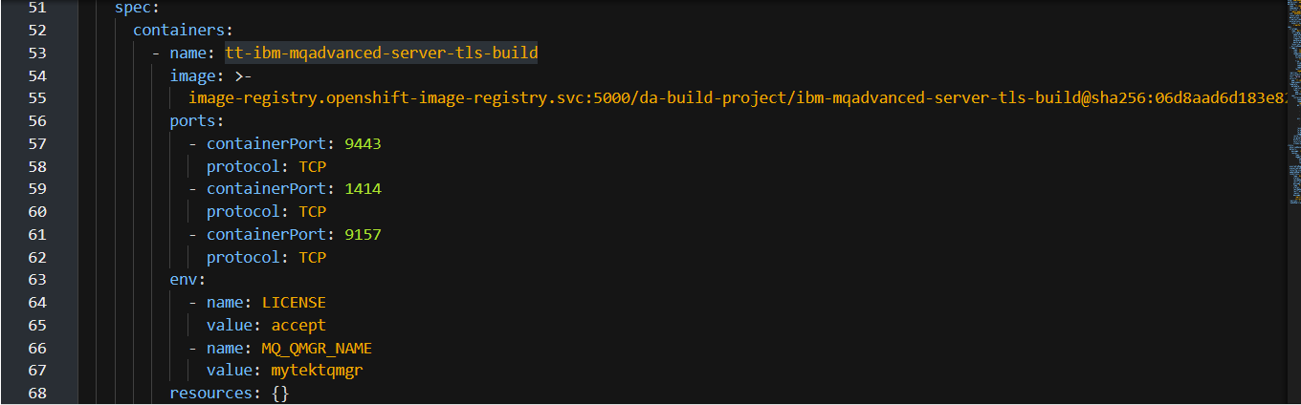

#### MQ container spec section – after

Add the volume under template->spec ahead of containers 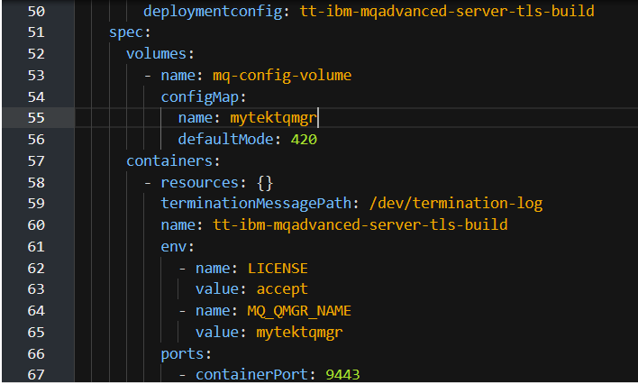

Add volumemounts after resources

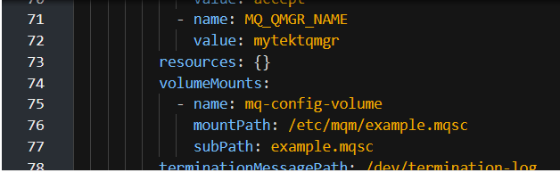

Save and reload

### Final DeploymentConfig for MQ to run MQSCs from ConfigMap

kind: DeploymentConfig

apiVersion: apps.openshift.io/v1

metadata:

name: tt-ibm-mqadvanced-server-tls-build

namespace: da-build-project

selfLink: >-

/apis/apps.openshift.io/v1/namespaces/da-build-project/deploymentconfigs/tt-ibm-mqadvanced-server-tls-build

uid: 0690b048-d512-4fba-8c1b-76adfb3d54de

resourceVersion: '10860610'

generation: 8

creationTimestamp: '2020-05-01T04:34:47Z'

annotations:

kubectl.kubernetes.io/last-applied-configuration: >

{"apiVersion":"apps.openshift.io/v1","kind":"DeploymentConfig","metadata":{"annotations":{},"name":"tt-ibm-mqadvanced-server-tls-build","namespace":"da-build-project"},"spec":{"replicas":1,"selector":{"app":"tt-ibm-mqadvanced-server-tls-build","deploymentconfig":"tt-ibm-mqadvanced-server-tls-build"},"strategy":{"activeDeadlineSeconds":21600,"resources":{},"rollingParams":{"intervalSeconds":1,"maxSurge":"25%","maxUnavailable":"25%","timeoutSeconds":600,"updatePeriodSeconds":1},"type":"Rolling"},"template":{"metadata":{"labels":{"app":"tt-ibm-mqadvanced-server-tls-build","deploymentconfig":"tt-ibm-mqadvanced-server-tls-build"}},"spec":{"containers":[{"env":[{"name":"LICENSE","value":"accept"},{"name":"MQ_QMGR_NAME","value":"mytektqmgr"}],"image":"image-registry.openshift-image-registry.svc:5000/da-build-project/ibm-mqadvanced-server-tls-build:latest","imagePullPolicy":"Always","name":"tt-ibm-mqadvanced-server-tls-build","ports":[{"containerPort":9443,"protocol":"TCP"},{"containerPort":1414,"protocol":"TCP"},{"containerPort":9157,"protocol":"TCP"}],"resources":{},"terminationMessagePath":"/dev/termination-log","terminationMessagePolicy":"File"}],"dnsPolicy":"ClusterFirst","restartPolicy":"Always","schedulerName":"default-scheduler","securityContext":{},"terminationGracePeriodSeconds":30}},"triggers":[{"type":"ConfigChange"},{"imageChangeParams":{"automatic":true,"containerNames":["tt-ibm-mqadvanced-server-tls-build"],"from":{"kind":"ImageStreamTag","name":"ibm-mqadvanced-server-tls-build:latest","namespace":"da-build-project"}},"type":"ImageChange"}]}}

spec:

strategy:

type: Rolling

rollingParams:

updatePeriodSeconds: 1

intervalSeconds: 1

timeoutSeconds: 600

maxUnavailable: 25%

maxSurge: 25%

resources: {}

activeDeadlineSeconds: 21600

triggers:

- type: ConfigChange

- type: ImageChange

imageChangeParams:

automatic: true

containerNames:

- tt-ibm-mqadvanced-server-tls-build

from:

kind: ImageStreamTag

namespace: da-build-project

name: 'ibm-mqadvanced-server-tls-build:latest'

lastTriggeredImage: >-

image-registry.openshift-image-registry.svc:5000/da-build-project/ibm-mqadvanced-server-tls-build@sha256:06d8aad6d183e82b11390eb3339598cec4b465f5cd61b9b54bb3159b90170f4c

replicas: 1

revisionHistoryLimit: 10

test: false

selector:

app: tt-ibm-mqadvanced-server-tls-build

deploymentconfig: tt-ibm-mqadvanced-server-tls-build

template:

metadata:

creationTimestamp: null

labels:

app: tt-ibm-mqadvanced-server-tls-build

deploymentconfig: tt-ibm-mqadvanced-server-tls-build

spec:

volumes:

- name: mq-config-volume

configMap:

name: mytektqmgr

defaultMode: 420

containers:

- resources: {}

terminationMessagePath: /dev/termination-log

name: tt-ibm-mqadvanced-server-tls-build

env:

- name: LICENSE

value: accept

- name: MQ_QMGR_NAME

value: mytektqmgr

ports:

- containerPort: 9443

protocol: TCP

- containerPort: 1414

protocol: TCP

- containerPort: 9157

protocol: TCP

imagePullPolicy: Always

volumeMounts:

- name: mq-config-volume

mountPath: /etc/mqm/example.mqsc

subPath: example.mqsc

terminationMessagePolicy: File

image: >-

image-registry.openshift-image-registry.svc:5000/da-build-project/ibm-mqadvanced-server-tls-build@sha256:06d8aad6d183e82b11390eb3339598cec4b465f5cd61b9b54bb3159b90170f4c

restartPolicy: Always

terminationGracePeriodSeconds: 30

dnsPolicy: ClusterFirst

securityContext: {}

schedulerName: default-scheduler

status:

observedGeneration: 8

details:

message: config change

causes:

- type: ConfigChange

availableReplicas: 1

unavailableReplicas: 0

latestVersion: 5

updatedReplicas: 1

conditions:

- type: Available

status: 'True'

lastUpdateTime: '2020-05-01T04:34:52Z'

lastTransitionTime: '2020-05-01T04:34:52Z'

message: Deployment config has minimum availability.

- type: Progressing

status: 'True'

lastUpdateTime: '2020-05-20T05:52:00Z'

lastTransitionTime: '2020-05-20T05:51:57Z'

reason: NewReplicationControllerAvailable

message: >-

replication controller "tt-ibm-mqadvanced-server-tls-build-5"

successfully rolled out

replicas: 1

readyReplicas: 1

### Check the Pod has restarted based on the Deployment Config change

Check RHOCP Console->workloads->pods

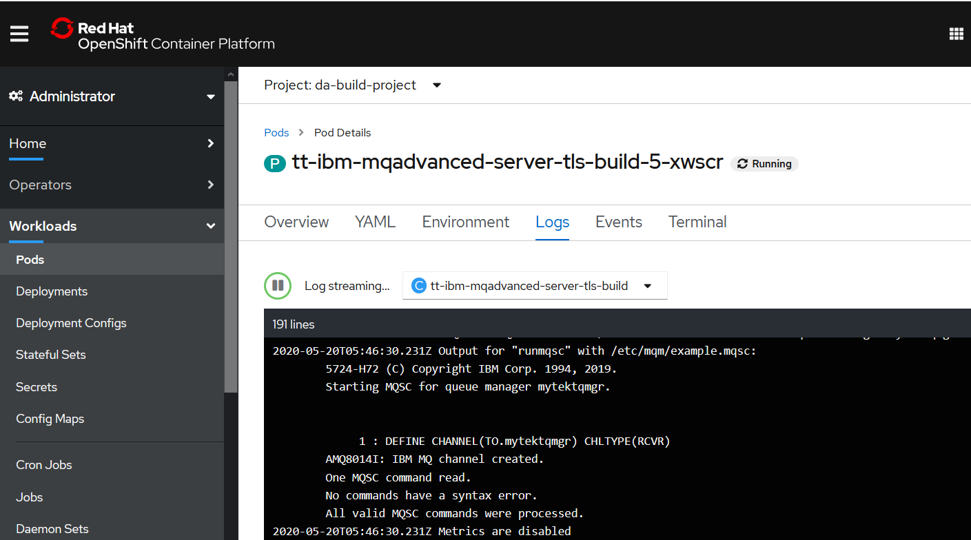

Note that the MQSC definition from the configMap is executed when the Pod restarts.

## Using Ansible to change the configMap

### Set up the baremetal command line environment

**You’ll need to make sure the baremetal server is still validly logged into the RHOCP cluster and in the right project with oc project da-build-project**

**ssh** [**root@135.90.77.114**](mailto:root@135.90.77.114)

**oc login --token=pMYUPsyAywHgvD3QqSCzQ_lItgKBeRB9LFhv1f7oQMU --server=https://c100-e.au-syd.containers.cloud.ibm.com:30178**

**oc project da-build-project**

### Using Ansible command line

Kubectl was installed under root user on baremetal server so update the hosts file with nano



### Quick connectivity test from Linux subsystem via baremetal

davearno@DESKTOP-2MFRK17:~$ ansible ibmbaremetal -m raw -a " oc get pods"

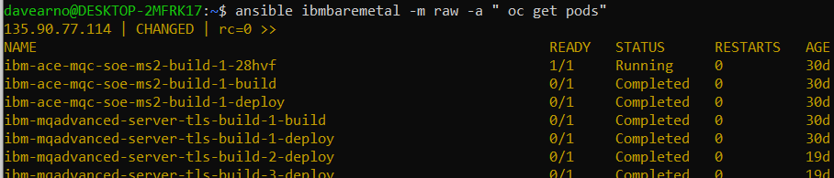

### Create/change the configMap MQSC YAML on the baremetal server

root@baremetal01:~# nano mytektqmgr-cm.yaml

and copy in:

kind: ConfigMap

apiVersion: v1

metadata:

name: mytektqmgr

namespace: da-build-project

data:

example.mqsc: >-

DEFINE CHANNEL(TO.ANS.mytektqmgr) CHLTYPE(RCVR)

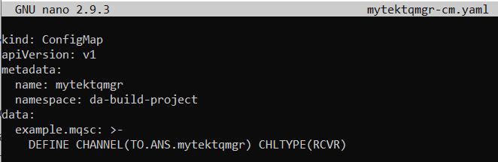

### Use ansible command line for the apply of the ConfigMap change from Linux subsystem

**ansible ibmbaremetal -m raw -a "oc apply -f mytektqmgr-cm.yaml”**



Check the configMap update in RHOCP Console->workloads->configMaps>mytektqmgr

Note the change in the data section

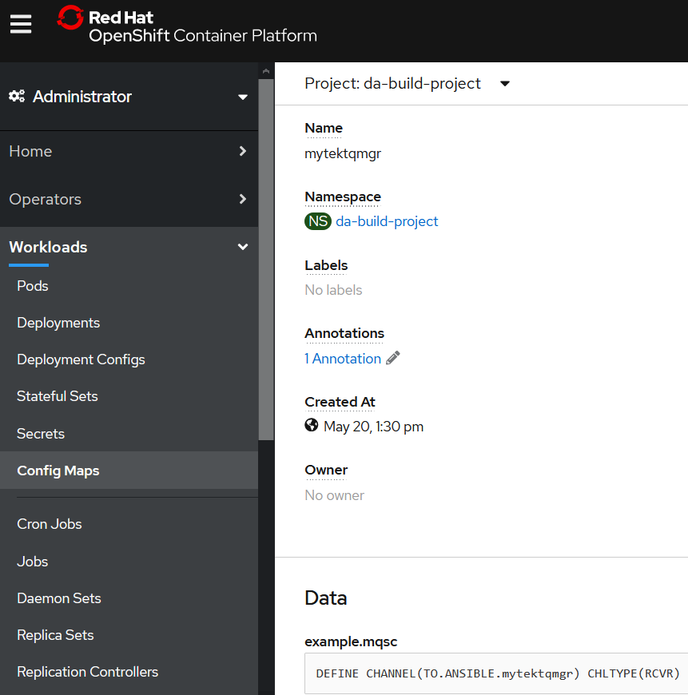

Check the Pods update in RHOCP Console->workloads->pods

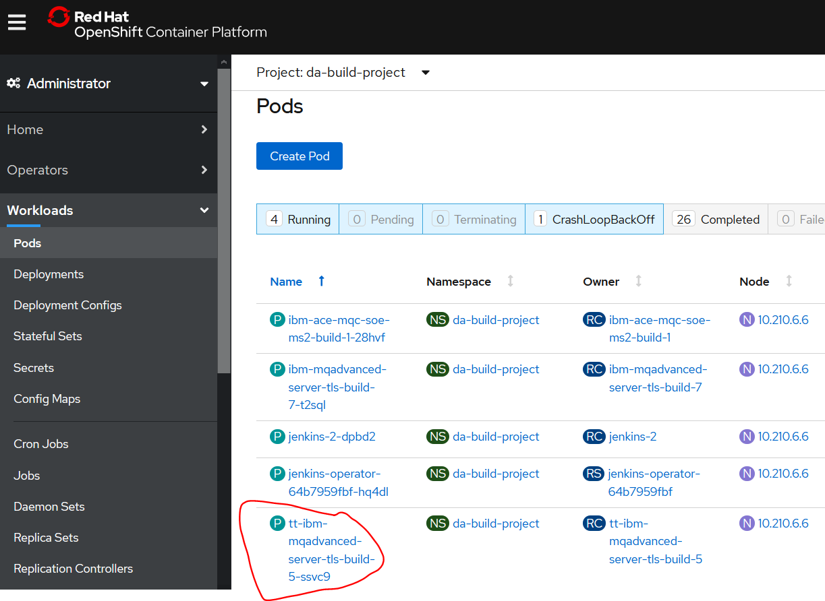

### Use ansible command line to restart the Pod from Linux subsystem

**ansible ibmbaremetal -m raw -a "oc delete pod tt-ibm-mqadvanced-server-tls-build-5-ssvc9"**



Check the Pods update in RHOCP Console->workloads->pods

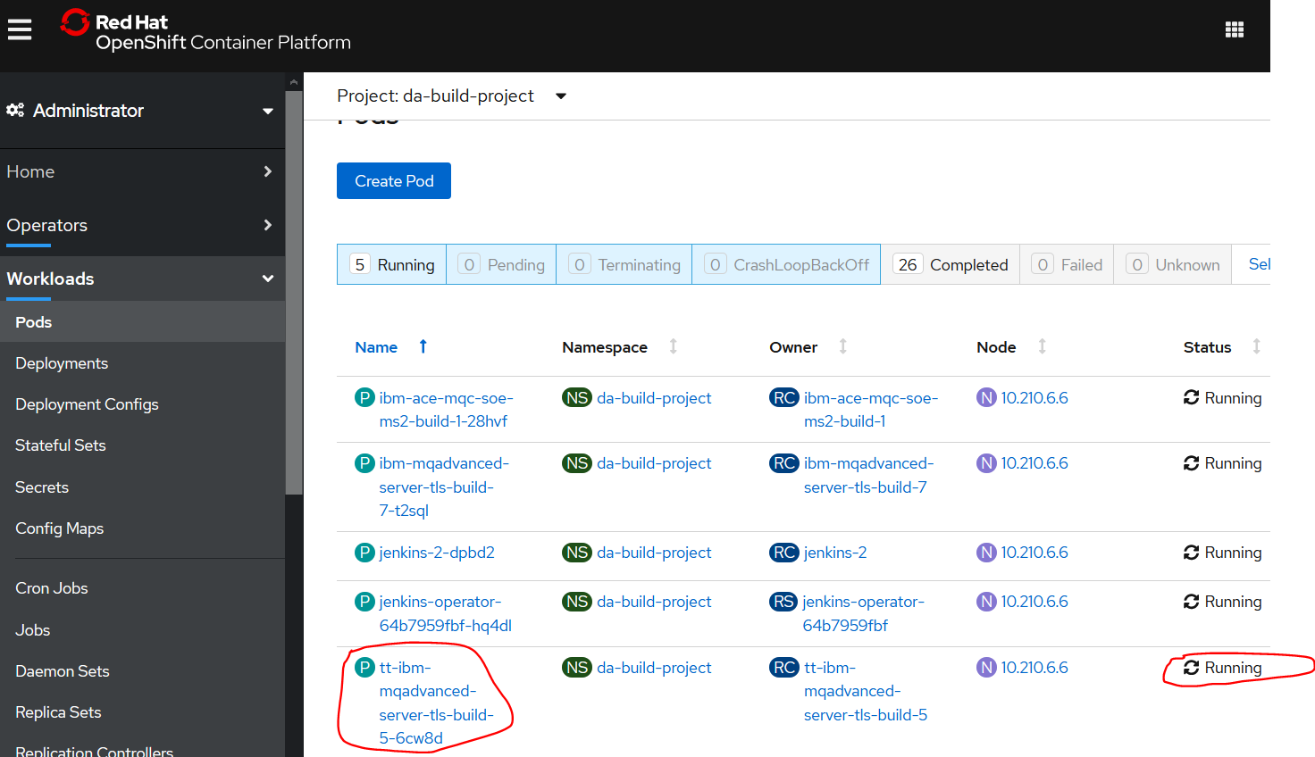

Check the pods logs to see the changed MQSC definition picked up.

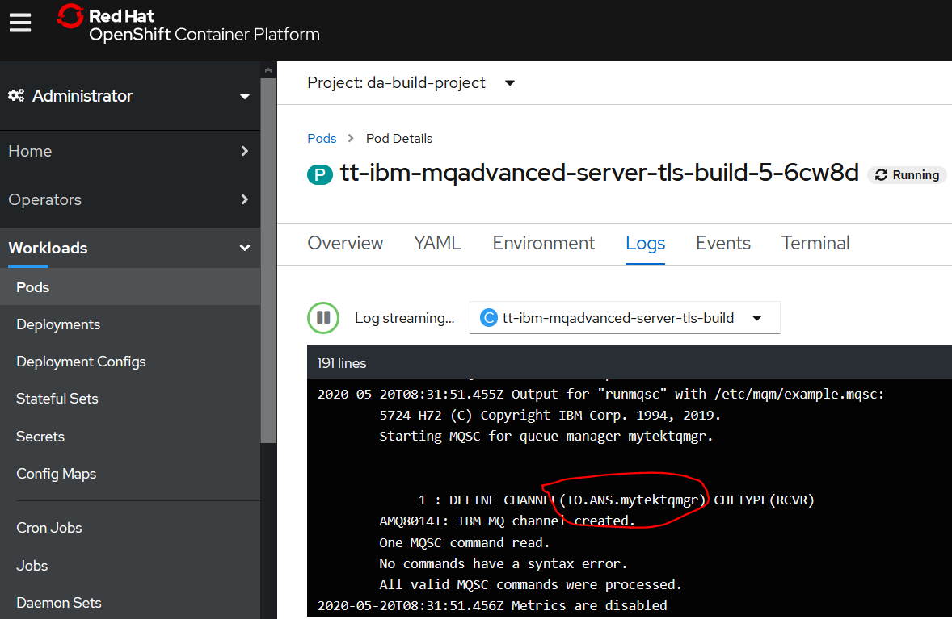

# Appendices

## Appendix A – bin/bash into containers

oc login --token=ZY5XX90OipG0tVuvA6JLPMS0e-hND_bmRaoHUZJ48Ps --server=https://c100-e.au-syd.containers.cloud.ibm.com:30178

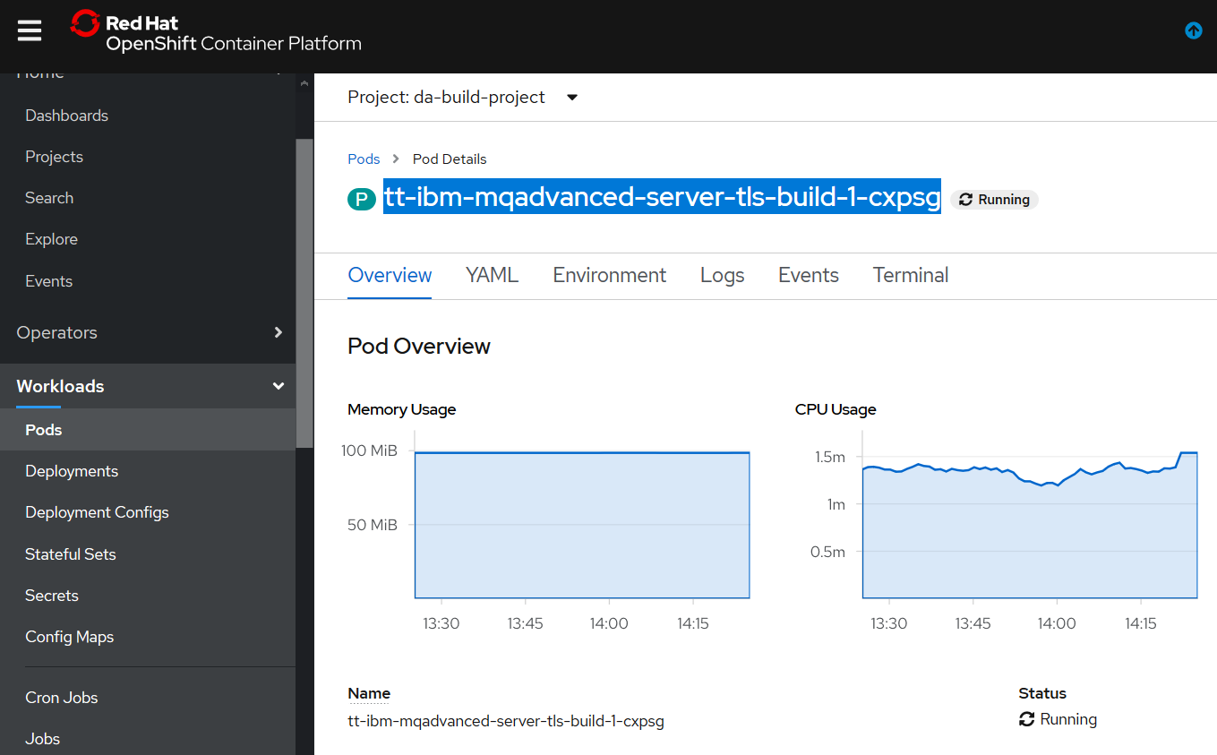

kubectl exec -it tt-ibm-mqadvanced-server-tls-build-1-cxpsg -- /bin/bash



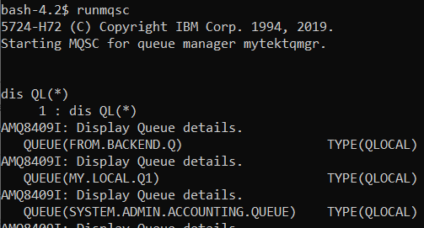

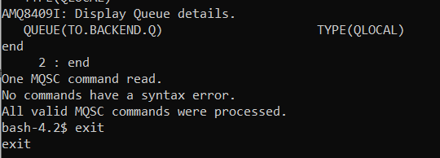

# Appendix B – MQSC files in Config maps

## Understanding the use of secrets to pass MQSC files at deploy time.

IBM MQ Offering Management architect has captured the steps for passing an MQSC file at deployment time such that a unique SVRCONN channel (has to be TLS enabled) can be created as part of the deployment. This avoids the need to create a custom image per queue within any single RHOS cluster. Connectivity for off-cluster MQ clients to queue managers in a cluster requires that TLS is used and that a SVRCONN with a name that matches the RHOS route name is used. Routes must have a unique name, therefore the SVRCONN must be unique.

It makes sense to leverage a naming convention where the Queue Manager name forms part of the route and as such the SVRCONN name. If using a custom image this SVRCONN definition can be hard coded and “baked” into the custom image for execution after the queue manager starts. However, this means we’d need a custom image per queue manager for that cluster.

The approach of passing in MQSC content as a configMap as part of a deployment “toolchain” means this MQSC content can be overridden at deployment time when the target queue manager name is known. This means the single supplied, certified MQ for ICP4i image can be used.

## Instructions for the use of a configMap to pass MQSC content

### Github repository source of instructions

<https://github.ibm.com/CALLUMJ/MQonCP4I/blob/master/instructions/configMap.md>

The preferred approach to adding custom MQSC to the certified container is documented [here](https://github.com/ibm-messaging/mq-container/blob/master/docs/usage.md#customizing-the-queue-manager-configuration).  
If clients insist that this is not feasible then it is technically possible to enable by using configMaps with customization of the helm chart.

## Downloading the helm charts

The IBM MQ Advanced helm charts are available [here](https://github.com/IBM/charts/blob/master/repo/entitled) and these instructions were created using [v5.0.0](https://github.com/IBM/charts/blob/master/repo/entitled/ibm-mqadvanced-server-integration-prod-5.0.0.tgz).

All the changes are within templates/stateful-set.yaml and an example is provided [here](https://github.ibm.com/CALLUMJ/ibm-mqadvanced-server-integration-prod/commit/1aa41bb9c076cae270570c81d4c010d32565018b)

### Create a configMap within OpenShift

1. Log into the OpenShift console and navigate to Workload --> ConfigMap:
2. Click Create Config Map and specify the following:

kind: ConfigMap

apiVersion: v1

metadata:

name: mqscconfigmap

namespace: mq

data:

example.mqsc: |-

DEFINE QLOCAL('ORG.DEAD.LETTER.QUEUE') REPLACE

ALTER QMGR DEADQ('ORG.DEAD.LETTER.QUEUE')

ALTER QMGR CONNAUTH('') CHLAUTH(DISABLED)

REFRESH SECURITY(*) TYPE(CONNAUTH)

DEFINE CHANNEL('ORG.APP.SVRCONN') CHLTYPE(SVRCONN) MCAUSER('mqm') REPLACE

DEFINE QLOCAL('MyApp.IN') REPLACE

The above creates a configMap called mqscconfigmap with the MQSC included within the example.mqsc section. In the case of your environment this would be customized based on your requirements. Please note that you need to create the ConfigMap within the correct namespace, in our case this was MQ.

1. Click Create.

### Customize the helm chart

1. Download the IBM MQ Advanced helm chart from [here](https://github.com/IBM/charts/blob/master/repo/entitled), and extract.
2. Open templates/stateful-set.yaml within your preferred editor and make the following changes:  
     
   The above is based on the assumption that you have not customized the configMap.

### Deploy the helm chart

1. Use the standard tools to deploy the modified helm chart to the CloudPak for Integration environment, for instance:

helm install ibm-mqadvanced-server-integration-prod --tls --namespace mq --name mq-helm-demo

--set license=accept --set pki.keys[0].name=default,pki.keys[0].secret.secretName=mqhacert,pki.keys[0].secret.items[0]=tls.key,pki.keys[0].secret.items[1]=tls.crt

--set image.repository="image-registry.openshift-image-registry.svc:5000/mq/ibm-mqadvanced-server-integration"

--set log.debug=false --set tls.generate=false --set tls.hostname=somewhere --set qmPVC.enabled=false

--set logPVC.enabled=false --set selectedCluster.label=local-cluster --set selectedCluster.value=local-cluster

--set selectedCluster.ip="" --set selectedCluster.namespace=local-cluster --set sso.webAdminUsers=admin1

--set sso.registrationImage.repository="image-registry.openshift-image-registry.svc:5000/mq/ibm-mq-oidc-registration"

--set queueManager.multiInstance=true --set odTracingConfig.enabled=false

## Instructions for off cluster MQ connectivity using configMaps.

Download the HELM chart for MQ from this URL:

<https://github.com/IBM/charts/blob/master/repo/entitled/ibm-mqadvanced-server-integration-prod-5.0.0.tgz>

1. Locate the values.yaml file and add the following *lines (in red only)* to the queueManager section to define a new configMap name parameter:

queueManager:

# name allows you to specify the name to use for the queue manager. Defaults to the Helm release name.

name:

# multiInstance specifies whether to run in multi-instance mode with an active and standby queue manager

multiInstance: false

*# config map name to pass in for initial configuration*

*mqscConfigMap:*

1. Locate the values-metadata.yaml file and add the following *lines* to the queueManager section to add metadata to the new config map name parameter:

*mqscConfigMap:*

*__metadata:*

*label: "MQSC Config Map"*

*description: "The config map name which holds the mqsc file for initial configuration"*

*type: "string"*

*required: false*

1. Locate the statetful-set.yaml and add the following *lines (in red only)* after the text below to add the config map volume :

securityContext:

fsGroup: {{ .Values.security.context.fsGroup }}

supplementalGroups:

{{- range $group := .Values.security.context.supplementalGroups }}

- {{ $group -}}

{{ end }}

volumes:

*- name: mqsc-configmap*

*configMap:*

*name: {{ .Values.queueManager.mqscConfigMap }}*

1. Add the following lines (in red only) in the stateful-set.yaml file to add a volume mount for the config map data (the MQSC you wish to run against the queue manager).

volumeMounts:

- mountPath: "/etc/mqm/example.mqsc"

subPath: example.mqsc

name: mqsc-configmap

1. Rename the helm release in the Chart.yaml file to something different from the original name so that we do not overwrite the IBM release version:

*name: ibm-mqadvanced-server-integration-prod-ivt*

1. Rename the top level directory of the uncompressed chart to the same name as in step 4.

Once the changes have been made, run the following command above the top directory of the uncompressed helm release (above the directory with the new name of the helm release)

*Helm lint ibm-mqadvanced-server-integration-prod-ivt*

You should see :

*==> Linting ibm-mqadvanced-server-integration-prod-ivt*

*Lint OK*

1. Run the following command above the top directory of the uncompressed helm release:

*Helm package ibm-mqadvanced-server-integration-prod-ivt*

This produces a ‘.tgz’ file of the same name as the helm release.

Make sure you’re logged into cloudctl on the openshift instance:

*sudo cloudctl login -a https://<icp-console.apps.{serverURL}> -u admin -p w0rk@IB33M -n mq*

1. Run the following command to upload the chart to the openshift:

*sudo cloudctl catalog load-chart --archive ibm-mqadvanced-server-integration-prod-ivt-5.0.0.tgz --repo local-charts*

Update your local repo cache so you can reference the new chart.

*Helm repo update*

1. Create a configmap in the OpenShift Console which will define a TLS-based channel as follows:

**Note that the channel security specifics below rely on the instructions in the document section ‘Supplying certificates for TLS to the Queue Manager via secrets’.

kind: ConfigMap

apiVersion: v1

metadata:

name: mqivt3

namespace: mq

data:

example.mqsc: >-

DEFINE CHANNEL(**IVT3**) CHLTYPE(SVRCONN)

SSLCIPH(TLS_RSA_WITH_AES_128_CBC_SHA256) CERTLABL('label1') SSLCAUTH

(OPTIONAL)

SET CHLAUTH(**IVT3**) TYPE(BLOCKUSER) USERLIST(nobody)

ALTER AUTHINFO(SYSTEM.DEFAULT.AUTHINFO.IDPWOS) AUTHTYPE(IDPWOS)

CHCKCLNT(NONE) ADOPTCTX(NO)

SET CHLAUTH(**IVT3**) TYPE (ADDRESSMAP) ADDRESS(*) MCAUSER('mqm')

REFRESH SECURITY TYPE(CONNAUTH)

The bolded characters ‘IVT3’ indicate the secure channel name which will be specific to your environment.

The above contents should be placed in a file <filename.yaml> on your local machine and then use the command:

*oc create -f <configmap_filename.yaml>*

1. Create a route for this channel using the following content

kind: Route

apiVersion: route.openshift.io/v1

metadata:

name: keytst

namespace: mq

spec:

host: **ivt3**.chl.mq.ibm.com

to:

kind: Service

name: **mqivt1**-ibm-mq

port:

targetPort: 1414

tls:

termination: passthrough

Note that the host name bolded characters in the above sample are specific to your channel name, as described here:

<https://www.ibm.com/support/pages/ibm-websphere-mq-how-does-mq-provide-multiple-certificates-certlabl-capability>

The bolded service name string in the above sample is specific to your release name as in <release_name>-ibm.mq

The above contents should be placed in a file <filename>.yaml on you rlocal machine and then use the command:

*oc create -f <route_filename.yaml>*

At this point you are ready to deploy the queue manager using the install script as follows. Note the addition of a new parameter in the script below:

--set queueManager.mqscConfigMap=mqivt3

*sudo helm install --name <release_name> local-charts/ibm-mqadvanced-server-integration-prod-ivt --set license=accept --tls --set productionDeployment=false --set image.repository=image-registry.openshift-image-registry.svc:5000/mq/ibm-mqadvanced-server-integration --set image.tag=9.1.3.0-r4 --set image.pullPolicy=IfNotPresent --set image.pullSecret=default-dockercfg-dg95m --set icp4i.namespace=integration --set sso.registrationImage.repository=image-registry.openshift-image-registry.svc:5000/mq/ibm-mq-oidc-registration --set sso.registrationImage.tag=2.2.0 --set sso.webAdminUsers="admin" --set sso.uniqueUserIdentifier="sub" --set tls.generate=true --set tls.hostname=icp-proxy.apps.mq.dev.atombr.com --set tls.secret=ibm-mq-tls-secret --set persistence.enabled=true --set persistence.useDynamicProvisioning=true --set dataPVC.name="data" --set dataPVC.storageClassName="gp2" --set metrics.enabled=false --set queueManager.name=<queueManager_Name> --set pki.keys[0].name=label1,pki.keys[0].secret.secretName=mqserverkey,pki.keys[0].secret.items[0]=tls.key,pki.keys[0].secret.items[1]=tls.crt --set resources.requests.cpu=100m --set resources.requests.memory=200Mi --set queueManager.mqscConfigMap=mqivt3*

*You will see a new release with a channel name as escribed in the yaml file*



**

## @DA@ notes on using configmaps with MQ and Tekton work

@DA@ looks to me like I should follow the intro link below instead of the helm approach described in the section above but leverage the detail from Callum’s github article. For the purposes of what I want to do I only need create a queue or perhaps a recever channel like TO.QM1 something very specific to that queue manager.

I’d need to do it all manually first and then workout how to get ansible to do it.

Seems to be,

Create the configmap via yaml file with embedded mqsc script (or create from mqsc file)

Create a deployment yaml (steal an existing MQ one) the Tekton pipeline modifies one , would base off that and add the configmap.

If I name the configmap by queue manager, the tekton pipeline could SED it at deployment time (I use a deploymentconfig (not a deployment) such that the a container with a QM1 would always pick up QM1configmap. That would have specific MQSC commands for that queue manager. A TO.QM1 recevier channel for example

So that would have us sorted first time QM1 is built.

To change the mqsc configuration, you’d update the config map and blow the pod away. (unless there is a “trigger” on configmap change in RHOCP

triggers:

- type: ConfigChange

<https://stackoverflow.com/questions/49870500/usage-of-openshift-configmaps-in-deploymentconfigurations>

step1: manually create a config map for MQ, named by queue manager name and include a TO.QM1 receiver (named) MQQM1.configmap contains TO.QM1, MQQM2.config,ap containers TO.QM2 receieer

step2: update the ibmmq.yaml deployment config to include the configmap reference. Tekton pipeline can SED __QMGRNAME__ and replace with the queue manager name in order to find the right.

Step 3: retest Tekton to make sure it still deploys and picks up the config.map.

Step 4: use anisble to kick off the pipeline (raw and kubectl)

Step 5: use ansible to change the configmap contents – see what happens. Can it trigger a restart with new config?

Of course probably best to do a non tekton. I.e.

Create a config map for myappqmgr to a new queue DEF QL(myCFMq)

manual change of an an MQ deploymentconfig to reference maappqmgr

restart the pod, see if it gets a new queue.

Manually change the config map.

Get ansible to change the config map

## Other links

<https://opensource.com/article/19/6/introduction-kubernetes-secrets-and-configmaps>

<https://www.ansible.com/managing-kubernetes-is-easy-with-ansible>